**Pearson Higher Nationals in**

**Computing**

Unit 03: Professional Practice

Assignment 01

Higher Nationals

Internal verification of assessment decisions – BTEC (RQF)

|  |  |  |  |  |  |  |  |  |
| --- | --- | --- | --- | --- | --- | --- | --- | --- |
| **INTERNAL VERIFICATION – ASSESSMENT DECISIONS** | | | | | | | | |
| **Programme title** | BTEC Higher National Diploma in Computing | | | | | | | |
| **Assessor** | Ms.Sandani Poornima | | **Internal Verifier** | | Mr .Lakindu Premachandra | | | |
| **Unit(s)** | **Unit 03: Professional Practice** | | | | | | | |
| **Assignment title** | **Work Related Learning Report: Design and Deliver a Training Programme** | | | | | | | |
| **Student’s name** | Ranudi Gayathmie Kariyapperuma | | | | | | | |
| **List which assessment criteria the Assessor has awarded.** | **Pass** | | **Merit** | | | | **Distinction** | |
|  | |  | | | |  | |
| **INTERNAL VERIFIER CHECKLIST** | | | | | | | | |
| **Do the assessment criteria awarded match those shown in the assignment brief?** | | Y/N | |  | | | | |
| **Is the Pass/Merit/Distinction grade awarded justified by the assessor’s comments on the student work?** | | Y/N | |  | | | | |
| **Has the work been assessed accurately?** | | Y/N | |  | | | | |
| **Is the feedback to the student:**  Give details:   * Constructive? * Linked to relevant assessment criteria? * Identifying opportunities for improved performance? * Agreeing actions? | | Y/N Y/N  Y/N Y/N | |  | | | | |
| **Does the assessment decision need amending?** | | Y/N | |  | | | | |
| **Assessor signature** | |  | | | | **Date** | |  |
| **Internal Verifier signature** | |  | | | | **Date** | |  |
| **Programme Leader signature** (if required) | |  | | | | **Date** | |  |

|  |  |  |  |
| --- | --- | --- | --- |
| **Confirm action completed** | | | |
| **Remedial action taken**  Give details: |  | | |
| **Assessor signature** |  | **Date** |  |
| **Internal Verifier signature** |  | **Date** |  |
| **Programme Leader signature** (if required) |  | **Date** |  |

Higher Nationals - Summative Assignment Feedback Form

|  |  |  |  |  |  |
| --- | --- | --- | --- | --- | --- |
| **Student Name/ID** | | Ranudi Gayathmie Kariyapperuma - KIR/X-00104243 | | | |
| **Unit Title** | | **Unit 03: Professional Practice** | | | |
| **Assignment Number** | | **1** | **Assessor** | |  |
| **Submission Date** | | 30.06.2023 | **Date Received 1st submission** | |  |
| **Re-submission Date** | |  | **Date Received 2nd submission** | |  |
| **Assessor Feedback:**   |  |  |  |  |  |  | | --- | --- | --- | --- | --- | --- | | **LO1 Demonstrate a range of interpersonal and transferable communication skills to a target audience** | | | | | | | **Pass, Merit & Distinction Descripts** | **P1** | **P2** | M1 | D1 |  |  | | **LO2 Apply critical reasoning and thinking to a range of problem-solving scenarios** | | | | | | | **Pass, Merit & Distinction Descripts** | **P3** | **P4** | M2 | M3 | D2 |  | | **LO3 Discuss the importance and dynamics of working within a team and the impact of team working in different environments** | | | | | | | **Pass, Merit & Distinction Descripts** | **P5** | **P6** | **M4** | **D3** |  |  | | **LO4 Examine the need for Continuing Professional Development (CPD) and its role within the workplace and for higher level learning** | | | | | | | **Pass, Merit & Distinction Descripts** | **P7** | **P8** | **M5** | **D4** |  |  | |  | | | | | | | |
| **Grade:** | **Assessor Signature:** | | | **Date:** | | |
| **Resubmission Feedback:** | | | | | | |
| **Grade:** | **Assessor Signature:** | | | **Date:** | | |
| **Internal Verifier’s Comments:** | | | | | | |
| **Signature & Date:** | | | | | | |

* Please note that grade decisions are provisional. They are only confirmed once internal and external moderation has taken place and grades decisions have been agreed at the assessment board.

**Assignment Feedback**

|  |  |  |  |
| --- | --- | --- | --- |
| **Formative Feedback: Assessor to Student** | | | |
| **Action Plan** | | | |
| **Summative feedback** | | | |
| **Feedback: Student to Assessor** | | | |
| **Assessor signature** |  | **Date** |  |
| **Student signature** |  | **Date** |  |

**General Guidelines**

1. A Cover page or title page – You should always attach a title page to your assignment. Use previous page as your cover sheet and make sure all the details are accurately filled.
2. Attach this brief as the first section of your assignment.
3. All the assignments should be prepared using a word processing software.
4. All the assignments should be printed on A4 sized papers. Use single side printing.
5. Allow 1” for top, bottom , right margins and 1.25” for the left margin of each page.

**Word Processing Rules**

1. The font size should be **12** point, and should be in the style of **Time New Roman**.
2. **Use 1.5 line spacing**. Left justify all paragraphs.
3. Ensure that all the headings are consistent in terms of the font size and font style.
4. Use **footer function in the word processor to insert Your Name, Subject, Assignment No, and Page Number on each pag**e. This is useful if individual sheets become detached for any reason.
5. Use word processing application spell check and grammar check function to help editing your assignment.

**Important Points:**

1. It is strictly prohibited to use textboxes to add texts in the assignments, except for the compulsory information. eg: Figures, tables of comparison etc. Adding text boxes in the body except for the before mentioned compulsory information will result in rejection of your work.
2. Carefully check the hand in date and the instructions given in the assignment. Late submissions will not be accepted.
3. Ensure that you give yourself enough time to complete the assignment by the due date.
4. Excuses of any nature will not be accepted for failure to hand in the work on time.
5. You must take responsibility for managing your own time effectively.
6. If you are unable to hand in your assignment on time and have valid reasons such as illness, you may apply (in writing) for an extension.
7. Failure to achieve at least PASS criteria will result in a REFERRAL grade .
8. Non-submission of work without valid reasons will lead to an automatic RE FERRAL. You will then be asked to complete an alternative assignment.
9. If you use other people’s work or ideas in your assignment, reference them properly using HARVARD referencing system to avoid plagiarism. You have to provide both in-text citation and a reference list.
10. If you are proven to be guilty of plagiarism or any academic misconduct, your grade could be reduced to A REFERRAL or at worst you could be expelled from the course

**Student Declaration**

I hereby, declare that I know what plagiarism entails, namely to use another’s work and to present it as my own without attributing the sources in the correct form. I further understand what it means to copy another’s work.

1. I know that plagiarism is a punishable offence because it constitutes theft.
2. I understand the plagiarism and copying policy of Edexcel UK.
3. I know what the consequences will be if I plagiarise or copy another’s work in any of the assignments for this program.
4. I declare therefore that all work presented by me for every aspect of my program, will be my own, and where I have made use of another’s work, I will attribute the source in the correct way.
5. I acknowledge that the attachment of this document signed or not, constitutes a binding agreement between myself and Pearson, UK.
6. I understand that my assignment will not be considered as submitted if this document is not attached to the assignment.

**ranudigk@gmail.com**

**Student’s Signature: Date:30.06.2023**

**(*Provide E-mail ID*) (*Provide Submission Date*)**

**Higher National Diploma in Business**

Assignment Brief

|  |  |
| --- | --- |
| Student Name /ID Number | Ranudi Gayathmie Kariyapperuma KIR/X - 00104243 |
| **Unit Number and Title** | **Unit 3: Professional Practice** |
| Academic Year | 2021/22 |
| Unit Tutor | Ms.Sandani Poornima |
| **Assignment Title** | **Work Related Learning Report: Design and Deliver a Training Programme** |
| Issue Date | 28/05/2023 |
| Submission Date | 30/06/2023 |
| IV Name & Date |  |

|  |  |
| --- | --- |
| **Submission format** | |
| The submission should be in the form of an individual report written in a concise, formal business style using single spacing (refer to the assignment guidelines for more details). You are required to make use of headings, paragraphs and subsections as appropriate, and all work must be supported with research and referenced using Harvard referencing system. Please provide in-text citation and a list of references using Harvard referencing system. Please note that this is an activity-based assessment and your report should include evidences to the activities carried out individually and/or in a group.  To carry out the activities given on the brief, you are required to form groups, comprising maximum of 6 members. | |
|  | **Unit Learning Outcomes:** |
|  | **LO1** Demonstrate a range of interpersonal and transferable communication skills to a target audience.  **LO2** Apply critical reasoning and thinking to a range of problem-solving scenarios.  **LO3** Discuss the importance and dynamics of working within a team and the impact of team working in different environments.  **LO4** Examine the need for Continuing Professional Development (CPD) and its role within the workplace and for higher-level learning. |
| **Scenario** | |
| Assume yourself as the event coordinator working in an event planning organization specialized in delivering trainings on IT and soft skills. you have been appointed to design and deliver a training event on IT /Soft Skills to an identified audience. You are required to complete the project within 2 months and the training plan and resources should be finalized as per the requirement of the client.  You are required to form a group of not more than 6 members in order to carry out the event. The event will be headed by an event manager/ leader and each group member will be assigned a set of tasks. While designing and delivering the event,   * the skills required to make the event successful * challenges faced during the design/ delivery * Critical evaluation of the problems, challenges faced and the methods used to overcome them * The need for continuously develop in a professional environment   Need to be thoroughly considered.  **At the end of the event, produce an individual report by each member covering the following tasks.**  **Task 1:**  Demonstrate how you are planning to effectively deliver the training event by designing a professional project plan with following details.   * Roles appointed to group members and an evaluation of interpersonal skills of each member that justifies the assigned role in the team. * Goal and objectives of the project * Evidences to the meetings conducted with the client and the team members and the findings/ outcomes of the meetings * Challenges/ problems identified and the plan to overcome them * A project schedule with the activities, milestones and contingencies identified.   **Task 2**  Researchdifferentproblem-solving techniques that can be used to solve the identified problems in task 1 anddemonstrate how critical reasoning can be applied to identify a solution to the identified problems.  Criticallyevaluate the solution methodology used to solve one of the identified problems and justifyhow selected methodology helped you to successfully solve the problem and achieve the project objectives.  **Task 3**  Work in your team by contributing your skills and knowledge to meet the project goal. Critically evaluate your own role and contribution to the group for the completion of the training event.  Discuss the importance of having dynamic team members in a group to meet its goals by referring to the role assigned to the group members and analyse how team dynamics among your group members effectively helped to achieve the shared project goal.  **Task 4**  Discuss with examples, the importance of continuous professional development (CPD) in a work setting by evaluating the range of CPD criteria that can be used to measure the effectiveness of your employees in your organization.  Produce a continuous professional development (CPD) plan using the criteria identified above with relevant to the responsibilities, required skills, performance objectives for the members of your team. Compare and contrast different motivational theories and discuss how they can be helpful to improve the performance of the team members and meet the objectives of the developed CPD plan.    - | |

**ACKKNOWLEDGEMENT**

At last author would like to share the experience while doing the project. Author learns many new things about the networking topics. The best thing which author can share is that author developed more interest in this subject. This Project gave author experience of how to do an event .

A very special thanks to Miss Sadani who teach us this subject and Author thanks for who helped author to do this kind of project. Thank you!

Regards,

The author,

Ranudi Kariyapperuma.

**Table of Content**

LO1: Interpersonal and transferable communication skills to a target audience. 17

About The Event 17

Some of Events Photos 18

Different communication styles and formats, that you can effectively design and deliver a training event for a given target audience. 19

Interpersonal and transferable communication skills 19

Interpersonal Communication skills 19

Transferable Communication Skills 20

Verbal Communication 21

Nonverbal Communication 22

Effective time management skills in planning an event. 22

Time Management?. 22

Importance of time management 22

Time Management of Authors Event 23

Time Management Skills and How Authors team archived It. 24

How The Authors Team managed time effectively 27

LO2: Critical reasoning and thinking to a range of problem-solving scenarios. 28

Demonstrate the use of different problem-solving techniques in the design and delivery of an event. 28

Explanation of Problem. 28

The Different Types of problem-solving techniques in the design and delivery of an Event . 28

Different problem-solving techniques used in the design and delivery of an event. 33

Critical reasoning has been applied to a given solution. & Apply Critical reasoning to a given task/activity or event. 36

Importance of Critical Path Analysis in Project Management 36

Critical Path Analysis of Authors Team 37

The importance of team dynamics in the success and/or failure of group work. & 40

Work with a Team to achieve a defined goal. 40

The meaning of Team ? 40

Team Dynamics 40

Team dynamics and in terms of the roles group members play in a team and the effectiveness in terms of achieving shared goals. 43

Tuckman’s Theory 43

o How Tuckman’s Theory used in the Event 44

Belbin’s Theory 45

The importance of CPD and its contribution to own learning. 49

• Continuing Professional Development (CPD) 49

• Importance Of CPD 50

How CPD Helpful to contributing to author’s own learning. 51

A development plan that outlines responsibilities, performance objectives and required skills, knowledge and learning for future goals. 52

A professional schedule to support the planning of an event, to include contingencies and justifications of time allocated. 53

Gantt Chart 53

The use and application of a range of solution methodologies. 54

Application of Solution Methodologies. 54

Differences between different motivational theories and the impact they can have on performance within the workplace. 55

Different Motivational theories 55

• Maslow’s Hierarchy of Needs 55

• Herzberg’s Two Factor Theory of Motivation 56

Motivational Theory Comparison 59

Maslow’s Hierarchy of Needs 59

Herzberg’s Two Factor Theory of Motivation 59

The effectiveness and application of interpersonal skills during the design and delivery of a training event. 65

A critical evaluation of Authors own role and contribution to a group scenario. 67

A range of evidence criteria that is used as a measure for effective CPD. 69

Event photos 75

References 93

**Table of Figures**

Figure 1 : Lederanza 2023 pic 1 18

Figure 2 : Lederanza 2023 pic 2 18

Figure 3 : Lederanza 2023 pic 3 18

Figure 4 : what is communication? (https://www.linkedin.com) 19

Figure 5 : Meetings Through WhatsApp 21

Figure 6 : Event Agenda 23

Figure 7 : Whatsapp conversations 24

Figure 8 : Brainstorming 29

Figure 9 : SWOT Analysis 30

Figure 10 : The 5 Whys Method 31

Figure 11 : The Drill Down Technique 32

Figure 12 : Critical Path Analysis (www.indeed.com) 36

Figure 13 : CPA Part 1 of Author’s Team 37

Figure 14 : CPA Part 2 of Author’s Team 38

Figure 15 : Belbin’s Theory 45

Figure 16 : Team roles using Belbin’s Theory 46

Figure 17: Continuing Professional Development Cycle 49

Figure 18 : Author’s Teams Gantt Chart 53

Figure 19 : Solution Methodology 54

Figure 20 : Maslow’s Hierarchy of Needs 55

Figure 21 : Herzberg’s two factor theory 56

Figure 22 : McClelland’s Theory of Needs 57

Figure 23 : Vroom’s theory of Expectancy 58

Figure 24 : McGregor’s theory X and theory Y 59

Figure 25: WhatsApp groups that used for the Event planning 69

Figure 26 : The authors teams WhatsApp group 69

Figure 27 : Authors teams Zoom meetings 70

Figure 28: Authors teams Meetings 70

Figure 29 : Event Permission Letter 1 71

Figure 30 : Event Permission Letter 2 72

Figure 31 : Authors Team Project proposal 1 73

Figure 32 : Authors Team Project proposal 2 74

Figure 33 : preparing the event 75

Figure 34 : Tie a colour ribbon to define the groups for each student 75

Figure 35 : Before the event 76

Figure 36 : The beginning of the event 76

Figure 37 : Presentations 77

Figure 38 : Paper tower challenge 77

Figure 39 : Sketch pen game 78

Figure 40 : Ballon hub game 78

Figure 41 : Feedbacks about the Event 1 79

Figure 42 : Feedbacks about the Event 2 80

Figure 43 : Feedbacks about the Event 3 81

Figure 44 : Feedbacks about the Event 4 82

Figure 45 : Feedbacks about the Event 5 83

Figure 46 : Feedbacks about the Event 6 84

Figure 47 : Feedbacks about the Event 7 85

Figure 48 : Feedbacks about the Event 8 86

Figure 49: Feedbacks about the Event 9 87

Figure 50 : Feedbacks about the Event 10 88

Figure 51 : Feedbacks about the Event 11 89

Figure 52 : Feedbacks about the Event 12 90

Figure 53 : Feedbacks about the Event 13 91

Figure 54 : Feedbacks about the Event 14 92

# LO1: Interpersonal and transferable communication skills to a target audience.

### About The Event

As the Professional practice module project our HND 10th Batch Organized a Leadership Training Programme to develop Leadership Skills. This Leadership Training Programme was focused for Ditec students of Esoft Metro Campus, Kiribathgoda. The Name of This programme is Liderenza . For this programme students were sepereted to 10 Groups But then from these groups selected only 5 Groups. In these 5 groups the students organised teams’ wise games for the event. So in the below mentioned are the teams and the games,

1. Team 1 – Crossing the blind through the galaxies.
2. Team 3 - Balloon line
3. Team 4 – sketchpen ball game
4. Team 6 – Follow the Lead
5. Team 10 – Paper tower Challenge

Before the games Our Hnd students planned to give the ditec students some details about leadership and for that decided to conduct a presentation as well. For that some of Hnd students were selected and others have to organised the game. So each games was planned for only 60-70 Ditec students . So for games each games divided into another 6 groups to identify each group students our hnd batch students plan to give the ditec students each them of a colour ribbon. Coloured ribbons that given to the ditec students are black,orange,light purple,blue,red and dark purple. That how the event was planned as a summery . So the author was in the Team 10. In team discussed how to plan the game and finally select the paper tower game . In this games for each group have to have 3 member or 6 members. Each group have to build the tallest tower in 15 minitues . After 15 minitues our hnd students choosen the group that made the tallest tower.

### Some of Events Photos

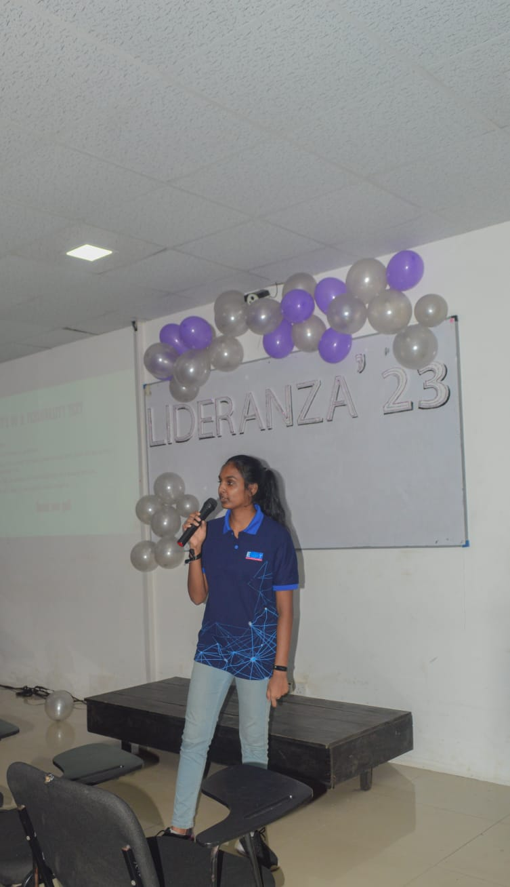

Figure 1 : Lederanza 2023 pic 1

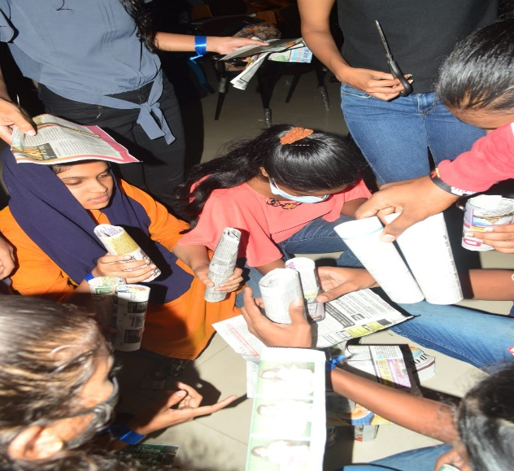

Figure 2 : Lederanza 2023 pic 2

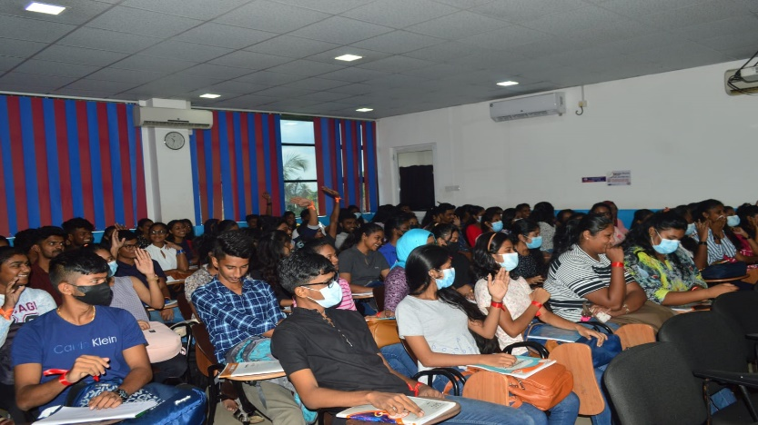

Figure 3 : Lederanza 2023 pic 3

## Different communication styles and formats, that you can effectively design and deliver a training event for a given target audience.

* **The Definition of Communication**

Simply A communication means that one person can exchange information, maybe feelings that kind of things to another person that’s called as a communication. Basically, there are many categories of communication Styles.



Figure 4 : what is communication? (<https://www.linkedin.com>)

### Interpersonal and transferable communication skills

#### Interpersonal Communication skills

Interpersonal communication, often known as face-to-face communication, is the process through which individuals communicate knowledge, sentiments, and meaning with one another. Non-verbal cues like tone of voice, facial expressions, gestures, and body language are also part of interpersonal communication. These cues are communicated in addition to the actual words that are said, or the language that is employed.

So as interpersonal skills ,

* + - 1. Active listening
      2. Teamwork
      3. Responsibility
      4. Leadership
      5. Patenting
      6. Flexibility

#### Transferable Communication Skills

Skills that can be used to a number of vocations and sectors are called transferrable skills. When applying for a new job, especially one in a different field, you might use transferable talents to highlight your prior expertise. Employers frequently want applicants who have great communication abilities, for instance. You may use them in any workplace if you've mastered the capacity to effortlessly communicate information with and among coworkers.

So transferable skills are,

1. Active listening
2. Computer skills
3. Planning
4. Organisation
5. Research
6. Writing

So in the authors team was have many skills on communication like confidence , present skills, good feedbacks like wise . Authors teams leader and the members were helpful to each other to make a successful output.

### Verbal Communication

“ [Technology is a compulsive and addictive way to live. Verbal communication cannot be lost because of a lack of skill. The ability to listen and learn is key to mastering the art of communication. If you dont use your verbal skills and networking, it will disappear rapidly. Use technology wisely.](https://www.azquotes.com/quote/1200070?ref=verbal-communication)” This was said by Rick Pitino.

So Verbal communication is a communicate information with spoken words to another person. It can be physically or virtually. In this programme authors group was communicate importance things through WhatsApp calls, Teams and also zoom app. Writers group leader was divided work for each and every one in this meetings.

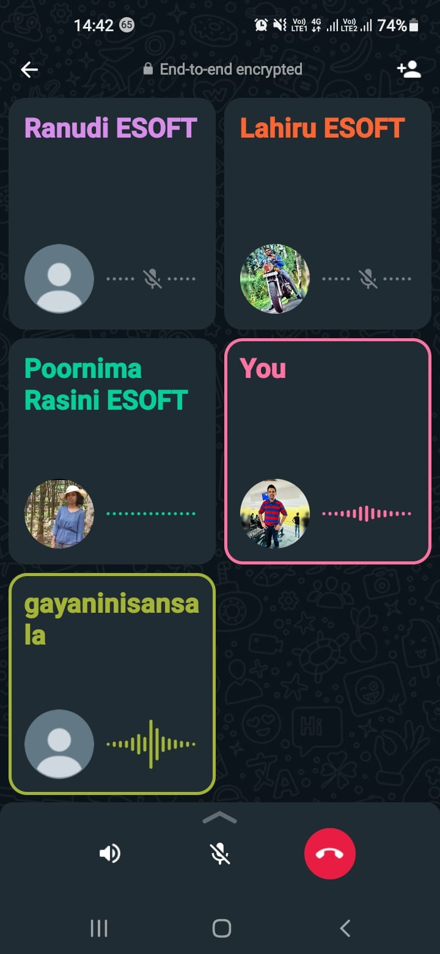

Figure 5 : Meetings Through WhatsApp

### Nonverbal Communication

“[Nonverbal communication is an elaborate secret code that is written nowhere, known by none, and understood by all.](https://www.azquotes.com/quote/1464114?ref=nonverbal)” This was said by Edward Sapir. In authors words a nonverbal communication means communicates without words like using facial expressions , Eye contacts, hand gestures also , body language etc.

In authors teams also users this type of communication during physical meetings. Other feelings and also can identify the likes or dislikes because of facial expressions. If anyone didn’t clear about the information’s The writes team leader always explain it again. It is very easy to communicate in physically and all writers team members were there to solve the all problem when came during the discussion of this event.

In the event also it is very helpful by using nonverbal communication during the decoration parts in the event.

## Effective time management skills in planning an event.

### Time Management?.

In order to optimize the impact of a person's efforts, tasks and activities are coordinated throughout the allotted time. In essence, time management is used to help people do more, better work in less time. To make the most of the time available, time management includes planning, organizing, and scheduling. Techniques for time management also take into account a person's unique circumstance as well as any applicable skills and traits.

### Importance of time management

Time management is significant because it gives people the opportunity to maximize their time by giving it a purpose. It is used in the corporate world to establish objectives and standards for organizations and the people who work for them. Employees with good time management abilities may produce high-quality work and accomplish their objectives. Time management also assists managers in identifying employee potential and establishing practical objectives. Employees with poor time management abilities miss deadlines, do subpar work, experience excessive tension and anxiety, and run out of time. Ineffective time management negatively impacts staff, management, and the business.

### Time Management of Authors Event

In this event Students of Hnd batch organizers organized the event as planed without wasting time . Before create the agenda firstly allocate the time to the presentations then each team divide the time for each games and after that organizers manage the other thing as the plan. As the event was planned this is how the time was allocate to each items,

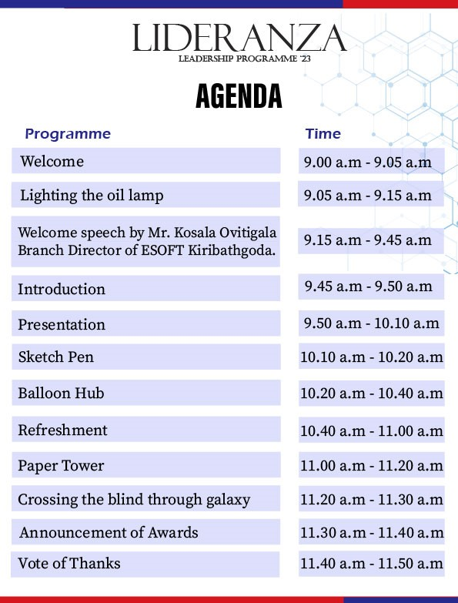

Figure 6 : Event Agenda

### Time Management Skills and How Authors team archived It.

In time management there are 9 types of skills that can save the time easily. The 9 type skills are known as

1.Organisation 5. Planning 9. Note taking

2.Prioritization 6.Delegation

3.Goal setting 7. Stress Management

4.Communication 8. Problem Solving

**1. Organisation**

In writers team members were all supportive and all the members did there best to do this event . So beginning of this programme the leader of writers group were assign work for the team members to do on time .

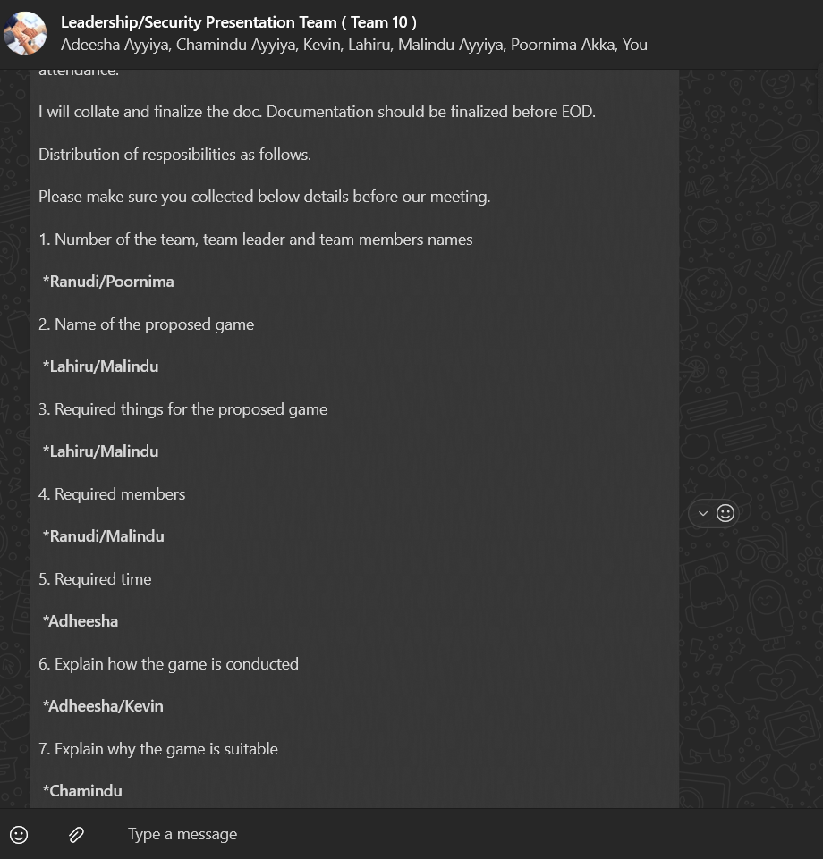

Figure 7 : Whatsapp conversations

**2 Prioritization**

Prioritization means that how the workloads divided into subcategories and how to do the

things correctly. In that case authors group was used the 4 theory of task prioritize. That

means,

|  |  |
| --- | --- |
| **Urgent & Important** | **Important & Not Urgent** |
| * Kick-off Meetings * Writing Project Proposal * Requesting Permission Letters * Prepare the Check List | * Designing the certificates * Rehearsal * Practice sessions * Event |
| **Urgent & Not Important** | **Not Urgent & Not Important** |
| * WhatsApp Group Calls * Zoom & Team Meetings * Group Chats | * Browsing Internet * Watching YouTube Videos * Playing Video Games |

Table 1: Authors Team Task Prioritization

**3 Goal Setting**

In Goal setting Authors group use SMART Goal system. In SMART Goals,

**S - Specific**

**M - Measurable**

**A - Achievable**

**R - Relevant**

**T - Time bound.**

These SMART Goals were firstly developed by Kenneth Blanchard and Spencer Johnson.

**Specific**

A lot more people are likely to succeed when their goals are precise. The five "W" questions must be considered in order to make a goal specific:

* Who is involved in achieving this objective?
* What is it that I hope to achieve?
* Where will this objective be attained?
* What motivates to accomplish goal?

**Measurable**

This SMART process step asks users to use tools for tracking the progress make toward that goal. Being quantifiable also takes into consideration any steps that might take to further your path to that goal. For instance, one may do this by keeping track of how long it takes people to do a task or reach a goal.

**Achievable**

refers to making sure the objective is doable to achieve or sustain within the given time range.

**Relevant**

Goals should be in line with the organization's mission. Don't use goal-setting as a mindless activity. Identifying the primary advantage to the company might help determine whether the aim is pertinent.

**Time Bound**

There should be a deadline for goals. Without a deadline, a goal is of limited value. What distinguishes success from failure? Because of this, S.M.A.R.T. goals have an end date. While this does not imply that the job is over, it does allow you to assess the project's progress and establish new objectives.

### How The Authors Team managed time effectively

1. Clearly defined and well-planned goals were set.
2. Set priorities, completed vital things first, and eliminated unimportant chores.
3. Set time constraints Group members received breaks from their assigned tasks.
4. Developed a pleasant working atmosphere.
5. Members of the group used social media infrequently.

# LO2: Critical reasoning and thinking to a range of problem-solving scenarios.

## Demonstrate the use of different problem-solving techniques in the design and delivery of an event.

### Explanation of Problem.

An issue that creates difficulty or problems is referred to as a problem. This state calls for a resolution or solution since there is a departure from what is wanted or anticipated. Problems can occur in a variety of circumstances, including those that are social, professional, personal, or technological. It might be anything from uncomplicated, easy-to-solve problems to intricate, multifaceted difficulties that call for considerable consideration and problem-solving strategies to properly handle. A broken equipment is an example of a physical problem. An interpersonal disagreement is an example of an abstract problem. Finding answers and obtaining desired results begin with recognizing and comprehending difficulties.

### The Different Types of problem-solving techniques in the design and delivery of an Event .

The Problem-Solving Tools are ,

1. **Brainstorming**

To solve problems in groups, brainstorming encourages impromptu contributions of original concepts and solutions. This method necessitates a thorough, unstructured debate in which each group member is encouraged to think aloud and offer as many ideas as they can, drawing on their varied backgrounds of knowledge. Brainstorming blends informal problem-solving techniques with lateral thinking, a technique for coming up with fresh ideas and approaches to issues. Some of these concepts may be incorporated into novel, inventive responses to issues, while others can spark new concepts.

**Types Of Brainstorms**

There are Two types of Brainstorm Methods. These are known as ,

1. **Reverse Brainstorming**

Instead of asking teams to brainstorm solutions, reverse brainstorming merely asks to do the opposite. Before the commencement of a significant project, teams engage in this kind of brainstorming to identify potential roadblocks. Use a Reverse Brainstorming Template to get the team thinking along these lines.

1. **Random word Brainstorming**

Upon receiving an issue, the team is instructed to yell out whatever phrases come to mind first. Then, these phrases are mixed into intriguing concoctions to see whether they would result in a workable solution. This approach of brainstorming is incredibly quick and frequently quite effective in resolving a specific problem. You can start by using the Random Words Brainstorming Template.

**Benefits of Brainstorming**

* + - 1. Can Improve Memory
      2. Problem Solving skills would be developed.
      3. It makes to Thinh Creatively
      4. Can improve Thinking Ability.
      5. Increases Productivity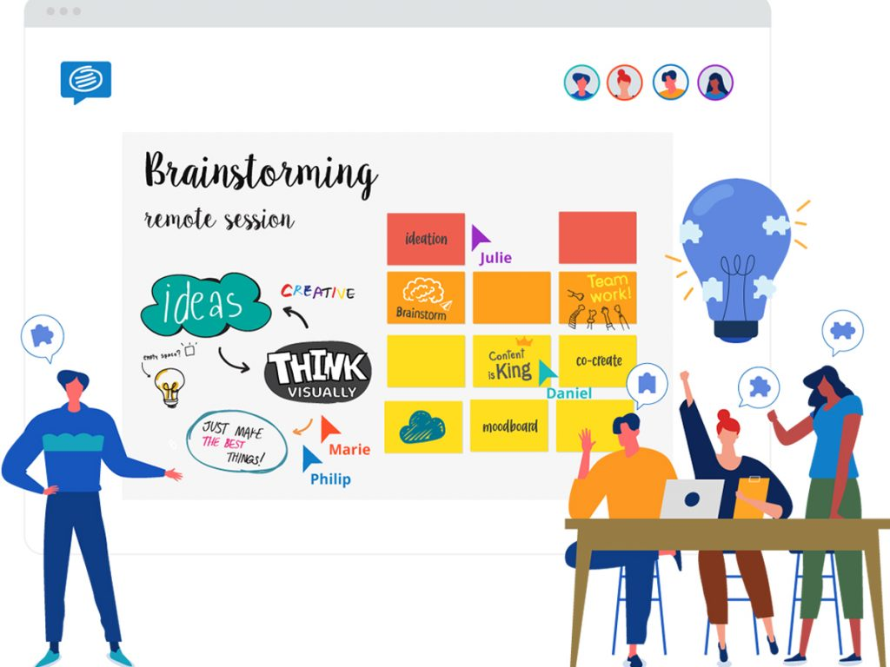

Figure 8 : Brainstorming

1. **SWOT Analysis**

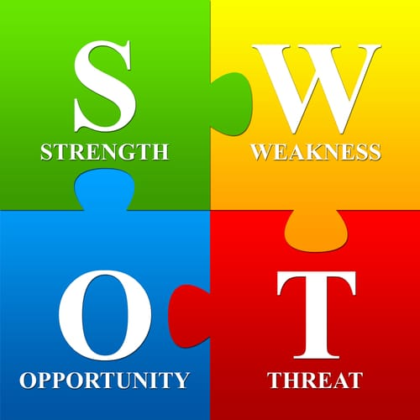

Figure 9 : SWOT Analysis

|  |  |
| --- | --- |
| **Strengths** | **Weakness** |
| * Good Leadership * Actively Listening * Positive Thinking * Shared the Knowledge to everyone | * Afraid of Public Speaking * Low energy * Disagrees with decisions sometimes |
| **Opportunities** | **Threats** |
| * Ability to work with others * Ability to organize an event * Can develop Interpersonal Skills | * Comparing with other teams. * Technical issues |

A SWOT analysis is a method of strategic planning that examines a company through the lenses of its strengths, weaknesses, opportunities, and threats. Users may enhance your user’s company's performance and take advantage of possibilities by doing a SWOT analysis. Users can also uncover potential threats to your success.

Table 2 : Authors Team SWOT Analysis

The authors team also used this method to solve the problems . In this below is the diagram that authors followed.

1. **5 Whys Method**

The five whys technique, also known as the five whys approach, is a root cause analysis strategy used in manufacturing that assists in identifying a problem's fundamental cause by repeatedly asking "why? Each query generates a follow-up query, creating a cause-and-effect chain that inexorably moves closer to the original cause. Even though it's commonly accepted that five questions are enough to get to the base of a problem, an analysis may nonetheless require more (or fewer) inquiries. The 5 whys chain may need to be divided into several levels or the complete analysis may need to be performed more than once if there are many root causes for the issue.

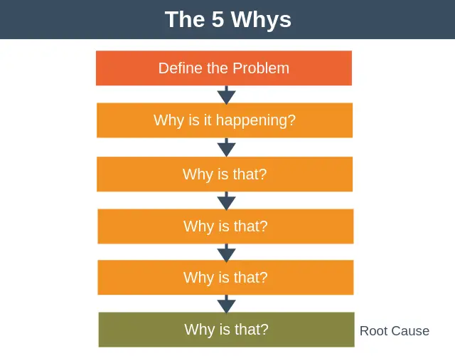

Figure 10 : The 5 Whys Method

**The Advantages of Five Whys**

Aids in determining the source of an issue.

Recognize how a single procedure may lead to a series of issues.

1. Identify the connections between several underlying causes.
2. Highly efficient without requiring complex assessment methods.
3. **The Drill Down Technique**

Drilling down to the source of the issue is a great approach to problem solutions. Although the issue troubling the business is frequently obvious, solving it successfully depends on identifying the root causes. With the overarching goal of solving the major problem, the drill down approach attempts to break the main problem down into its constituent parts and subsequently identify a solution to these aspects.

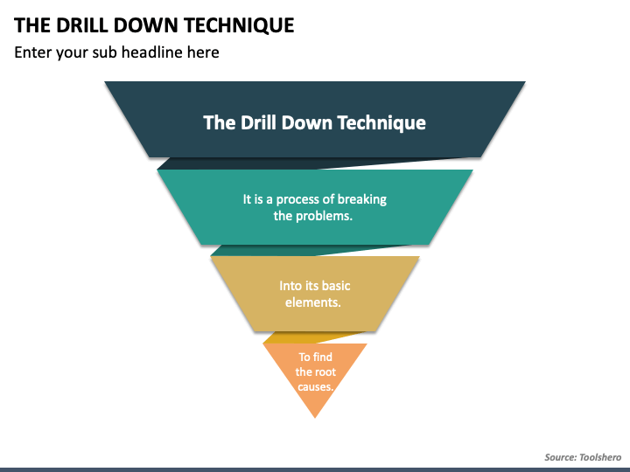Figure 11 : The Drill Down Technique

## Different problem-solving techniques used in the design and delivery of an event.

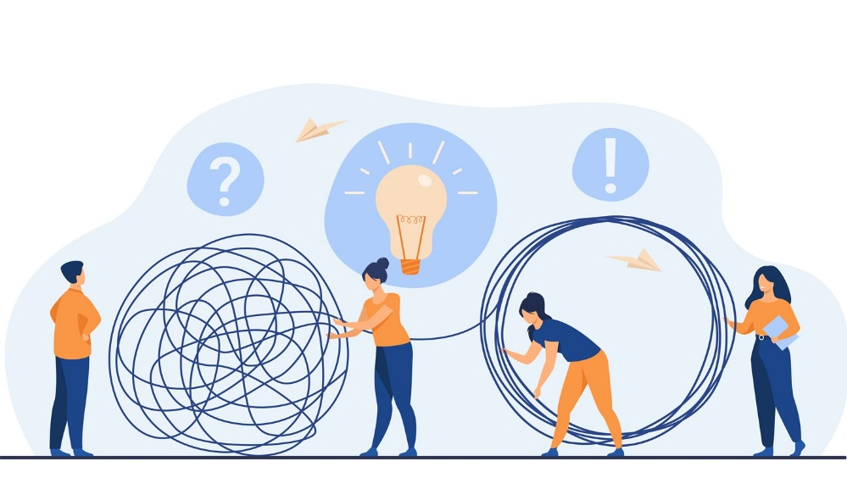

Figure 12 : Problem solving.

When organising the event there was many problems. Such as,

* How to choose the audience for the event.
* Selected audience have to understand of the event.
* The event have to be helpful to the audience and learn it through for the future

So that HND members were organized a leadership programme. As members were discussed the members and the lecturer suggest that it is better to do a event for O/l and A/l Prefects of a school. Members were chosen a school and also get the permission letter from the ESoft and from the school as well but unfortunately the school were unable to do the event that they gave for us because of that HND members were discussed immediately and selected ESOFT Ditec students as the Audience of the Event .

Also HND members have another problem that if the presentation cannot understand by the audience how to present it. For that purpose presenters were used both languages to get the idea what the event was for the audience and also to make it more understandable some presenters were used dialogs , some presenters were used story telling method and also some presenters were used question and answer method .

That are the Main problems that have in the Event the small problems that have are like how many equipment’s need to have in a group for the games like wise. Now the author explain how the HND students used the techniques to solve the problems

* + - 1. **Using Brainstorming in Leadership Programme**

Brainstorming sessions played a central role in the success of the leadership event organized for Dtec students at Esoft. This ideation technique has encouraged open and creative thinking within the organizational team, fostering the generation of creative ideas and solutions.

**Example:**

Before finalizing the program for the event, HND students held brainstorming sessions to design engaging and impactful activities for attendees. They encourage all team members to freely contribute their opinions without judgment. Following these brainstorming sessions, they came up with a number of unique team-building exercises and leadership simulations that enhanced the overall event experience. This approach allows HND students to harness the collective creativity of their group and provide Dtec students with an in-depth and memorable leadership event.

* + - 1. **Using SWOT Analysis in Leadership Programme**

SWOT analysis, a strategic planning tool, played a vital role in the success of the leadership event organized for Dtec students at Esoft. This involves assessing the internal strengths and weaknesses of the event and identifying external opportunities and threats to make informed decisions.

**Example:**

Prior to the event, HND students conducted a comprehensive SWOT analysis to assess the planning and execution of the event. They noted that one of their strengths was the diversity of skills among the organizers, which enabled them to effectively manage different aspects of the event. However, they acknowledged the weakness of the limited budget for some activities. In response to the opportunities, they noted a growing focus on student leadership development. However, they also recognize the risk of potential scheduling conflicts with the participants' other academic commitments. Armed with this analysis, the HND students played to their strengths, creatively managed their budget, and adjusted the event schedule to attendee availability, resulting in a well-received and well-attended leadership event.

* + - 1. **Using 5 WHYS Method in the Leadership Programme**

Method 5 Whys, a problem-solving method, was effectively used in a successful leadership session organized for Ditec students at Esoft. This method involves repeatedly asking "why" to find the root cause of the problem and find appropriate solutions.

**Example:**

During the event, the registration process was delayed, which caused inconvenience to the participants. HND students used the 5 Reasons Method to identify the root cause of a problem. They asked "why" the registration process was delayed and discovered that the online registration system was experiencing technical problems. They further asked "why" the system crashed and realized that it was due to a recent software update. By repeatedly asking "why", they were able to identify the root cause and quickly roll back to an earlier stable version of the software, effectively resolving the registry issue.

**4. Drill Technique in the Leadership Event**

Drilling Technique, also known as Root Cause Analysis, was used effectively by HND students in an organizational leadership event for Dtec students at Esoft. In this method, the problems and opportunities of the event are systematically analyzed to determine the root causes and possible solutions.

**Example:**

During this event, active participation in some sessions decreased significantly. To solve this problem, the HND students used the drilling technique to break the problem down into smaller components. They found that the lack of interactive elements and engaging activities in these sessions reduced the interest of the attendees. So, they quickly remedied this by incorporating interactive games and group discussions into the following lessons, which helped Ditec students to increase their engagement and enthusiasm.

## Critical reasoning has been applied to a given solution. & Apply Critical reasoning to a given task/activity or event.

**Critical Path Analysis (CPA)**

The important tasks required to finish a project must be mapped out as part of the critical path analysis (CPA) project management approach. It involves calculating the time needed to complete each task as well as any relationships between tasks. CPA, often referred to as the critical path approach, is a technique used to determine a project's realistic deadline and monitor its progress over time.

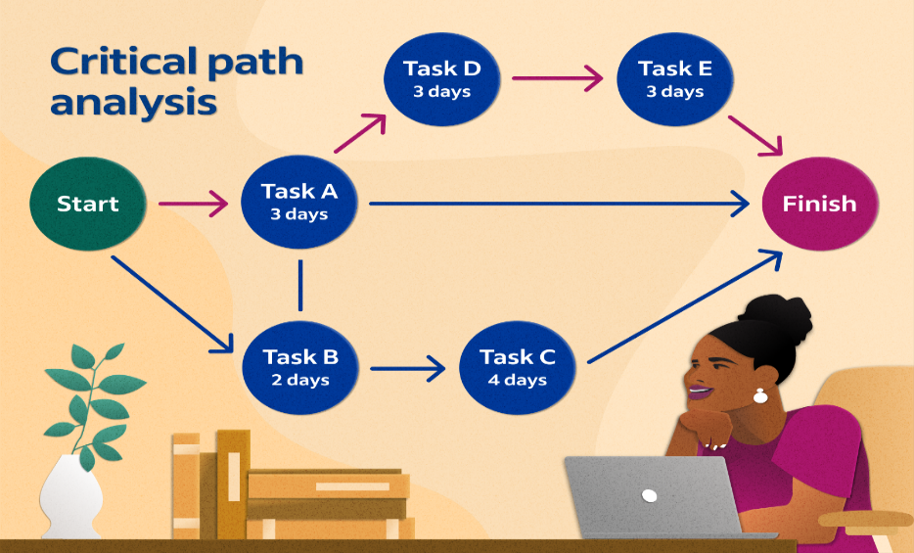

Figure 13 : Critical Path Analysis ([www.indeed.com](http://www.indeed.com))

### Importance of Critical Path Analysis in Project Management

One of the strategies used a lot in project planning is the critical route method. Project managers struggle to keep track of everything since a typical project involves several tasks involving a wide variety of personnel. Certain activities might far too easily become lost in the sea of never-ending tasks and fall behind. These overlooked duties and poor planning can have a significant impact on the project's timeline. A late project will cost money and result

in dissatisfied clients and superiors. In project management, the critical route methodology aids managers in determining two crucial factors. How long the project will take to finish, and which activities are the most important to do before beginning other related work. (Kenton, 2021)

### Critical Path Analysis of Authors Team

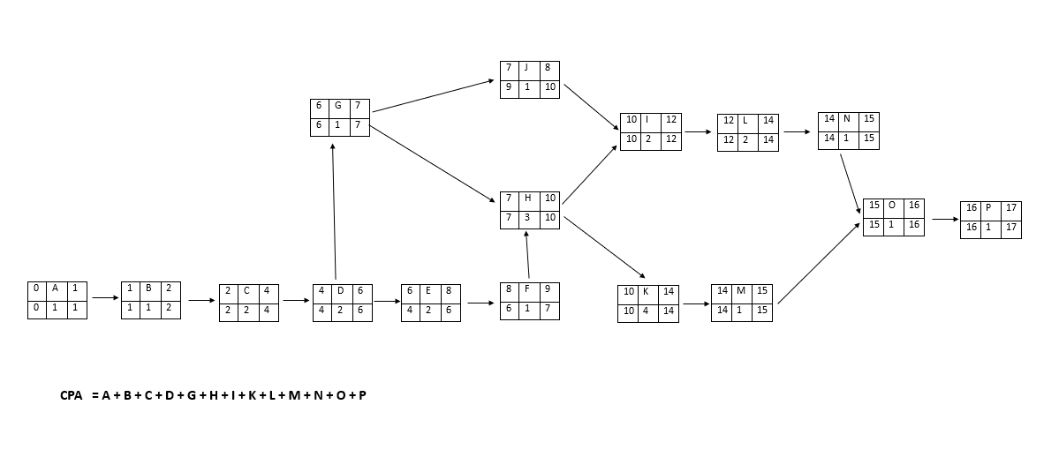

Figure 14 : CPA Part 1 of Author’s Team

In Critical Path Analysis Author used 16 Activities and to identify them author used Alphabet letters .In the First activity named as A is Undertaking Project so our team leader assigned 1 day as duration because it didn’t take time. In B activity Kickoff Meeting . In here before starting Kickoff meetings authors teams search about it after that started kickoff meetings so it is a sub activity in an activity it also take one day. In C activity according to the things that talk about in the kickoff meetings authors team members arrange a relevant schedule for that add 2 more days. Then in Activity D should write a the project proposal in here as team members discussed according to the scheduled team leader assigned 2days for this activity. According to the Project proposal then in Activity E Team leader assigned to get permission to do this event for that it also assigned 2 days in F it says the granting the permission so in G them get the approval of project proposal in 1 day .

Then After that in H need to search and select the audience relevant to the project proposal and also need the permission to it from the Esoft. Then in I need to prepare the certificates but it is not need immediately but it assigned 2 days for it. Then prepare the checklist according to the project proposal in one day. Then after that in K need to prepare for the presentation for the selected audience. Then in L need to make the budget according to the checklist and other things for that assigned 2 days. Then for Rehearsal it assigned 1 day . In N there said that prepare the necessary items for the event according to the budget. Then the result of rehearsal and after preparing the necessary things members can do the Event and it take one day after that in 1 day members can get the Feedbacks from the students of Ditec.

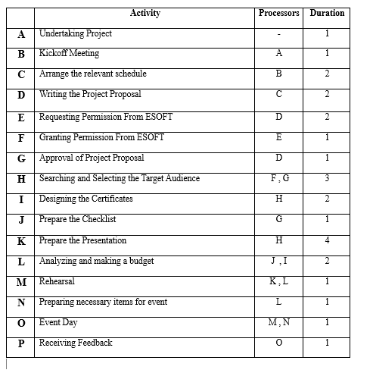

Figure 15 : CPA Part 2 of Author’s Team

## Backup Plans

|  |  |
| --- | --- |
| Component | Backup plans |
| * When a presenter was absent. | * Assigned 2 of members before the event and that members also practice them. |
| * Wheather Condition | * If the event day is a rainy day members should also have to ready to do the event in indoor if it is a outdoor event. |
| * When there is no sound in mics | * To that in authors event members were prepared two mikes. |
| * When there is a Power Cut in that Time Period | * Then there should have a generator to power supply. |
| * If the Chief Guest isn’t there at the time or delay | * Then as a backup plan have to do a speech or give a idea of the event . |
| * In the event if a game was delay. | * Then that time it should have do in a short time period. |

## 

## The importance of team dynamics in the success and/or failure of group work. &

## Work with a Team to achieve a defined goal.

### 

### The meaning of Team .

To fulfill a shared mission or goal, a team is made up of individuals who work together on a variety of interdependent duties. In a large corporation with several teams, careful alignment is necessary. The fundamentals of building understanding and trust will still apply when teams and people join with other teams, but the structure will become more complicated . The usefulness of teams becomes clear when one considers the various interconnections that exist among organizational components and processes as well as how these connections affect quality, productivity, and cost.

### Team Dynamics

The broad idea of "team dynamics" refers to how team members interact with one another as well as the psychological processes that underlie these interactions. Because team members' behaviors are interdependent throughout work projects, attitudes, motivation, and cognition that affect how they feel about each other, their team, and team projects arise because of these interactions.

Team members are more likely to feel satisfied and invested in their work when team dynamics are positive because they can accomplish their goals more quickly and effectively. The effectiveness of individuals and teams in achieving goals and finishing tasks increases by more than 50% when a team function well.

These days, a lot of company leaders think that teamwork opens up exciting new business opportunities and fosters innovation within their companies. Improved cost effectiveness, employee retention, and even greater consumer loyalty may result from these advantageous new dynamics.

**Key aspects of Team Dynamic**

* Communication

For a team to function successfully, communication must be effective. This involves expressing thoughts clearly, actively listening, and offering criticism.

* Trust

Without fear or embarrassment, team members must feel secure and at ease when exchanging ideas and information. Improved ideas and creativity are the result of established trust. In addition to overseeing ensuring that everyone is involved, engaged, and on time, a team leader must concentrate on elements that enhance team dynamics.

* Roles and Responsibilities

Author can ask one of your team members to explain their tasks and roles Would one of authors team members be willing to explain the duties and functions of each other team member, including the team leader? An effective team member understands what is required of them and every other team member when they can do this. Additionally, the authors team members are aware of who to contact  run into issues at work, which fosters positive team dynamics.

* Diversity and Inclusion

Having a variety of perspectives and ideas can result in original and creative solutions. Diversity in a cross-functional team concentrates on elements that improve team dynamics. For example, one might combine team members from multiple departments, each with their own viewpoints and abilities

* Accountability

For their work, employees should take accountability. If they perform well, they should be rewarded. It's a good idea to speak with them first, identify the issue, and implement a solution if there are any mistakes or weaknesses.

* Efficiency

How employees collaborate and the outcomes they produce matter more than how much time they spend doing so. It’s important to be careful about the working time.

**Types of Groups**

There are mainly two types of groups . These are known as formal groups and informal groups.

* + - 1. **Formal Groups**

A formal group is a group of people who have come together to work toward a common objective. Every time they are made, it is to satisfy a formal necessity. Group formation is handled by management. It has a structured, hierarchical organization.  
  
The organization's employees are typically separated into groups, and each group is given a task to complete. In this manner, the group's task and organizational objectives are both fulfilled.

* + - 1. **Informal Groups**

Informal groups are ones that naturally arise inside an organization as a result of social and psychological factors. Without the permission of management, employees of the organization form groups on their own to satisfy their social demands at work.

People frequently create a circle about themselves to interact and exchange ideas, emotions, experiences, knowledge, etc. No one desires a solitary existence. At work, we refer to these affiliations as informal groups. Based on the participants' similar preferences, prejudices, contacts, languages, pastimes, and attitudes, these groups are formed.

**Group Size**

When considering the group size in Authors Event the Lecturer consider that A group must Have maximum 10 members each group. If the Members of a group exceed, then there can be a risk of higher workload stuff then also hard to work all of them in a group.

## Team dynamics and in terms of the roles group members play in a team and the effectiveness in terms of achieving shared goals.

### Tuckman’s Theory

In 1965, Bruce Tuckman created this model for the first time. One of the more well-known theories of team development has served as the foundation for several other theories since its inception. From the time a team is formed until the project is finished, Tuckman's theory focuses on how a team approaches a task. To cover the completion of a work, Tuckman later introduced a fifth step, Adjourning and Transforming. Tuckman's theory is especially applicable to team-building exercises since the stages are involved in finishing any activity a team takes on. Now in below the steps of Tuckman’s theory will discussed.

* **Forming**

Assembling the team and assigning the work. Team members frequently act autonomously, and despite possible goodwill, they may not know one another well enough to fully rely on them. Planning, information gathering, and bonding take up time. In authors event to divide groups authors lecturer write 6 chits and students were piciking a chit through it then when get a one chit there is a number that is the group number that how the groups were formed.

* **Storming**

Assembling the team and assigning the work. Team members frequently act autonomously, and despite possible goodwill, they may not know one another well enough to fully rely on them. Planning, information gathering, and bonding take up time. The group gets to work on the project by offering suggestions. Different ideas may strive for supremacy, and if this phase is poorly managed, it might be highly damaging to the team. During this period, team relationships will be formed or destroyed, and some may never mend. The team may become caught in the storming phase in unusual circumstances. For the sake of the team, a team that is overly focused on agreement may choose a strategy that is less efficient in accomplishing the goal. This has a unique set of issues. In this stage, a team must have strong facilitative leadership. In Authors group as storming all group members have various kinds of things and suggest lots of things to do and also suggest various kinds of games to do. In this term it is difficult to get into a single idea because of that as a group we gathered all the group members ideas and then we choose the best idea of it.

* **Norming**

The team will transition from the Storming phase into the Norming phase. Teams tend to agree on the principles and norms by which they do their business, which tends to lead to more pleasant working practices. As they acknowledge the crucial contribution made by each team member, teams should ideally start to trust themselves at this phase. At this point, when each team member assumes more responsibility, team leaders might withdraw from the group. In a Authors group as the theory of norming Authors group team leader was assigned every one a role and each member should have to do the work properly at the time also as the rules team leader told us to work on the day and all members should do every work.

#### How Tuckman’s Theory used in the Event

**Number of participants:**

people. In the first stage, the group was formed and tasks were assigned to each member. At this stage, team members often operate independently and, despite their best intentions, may not know each other well enough to trust each other's abilities. The team spends time planning, gathering information, and building relationships among members.

**Storming:**

In the storming phase, the group members started to work by sharing their ideas. Different perspectives and approaches can compete for dominance, and if not managed well, this phase can be very detrimental to the team. At this stage, group relationships may develop or disintegrate and conflicts may arise. In difficult situations, the team can block the storm phase and prevent progress. At this stage, strong supportive leadership is essential to guide the team toward a constructive resolution of the conflict.

**Recovery:**

When the team exits the charging phase, it enters the recovery phase. At this stage, the team tends to reach an agreement on the principles and standards that govern their work, which leads to smoother and more cohesive collaboration. Ideally, team members trust each other's contributions and strengths. As trust builds, team leaders can step back and team members can take more individual responsibility in their roles.

During a successful leadership event held by HND students for Dtec students at Esoft, Tuckman's team development theory was used effectively to guide teams through these important steps. During the training phase, teams are carefully assembled and tasks are assigned based on individual strengths and interests. During the attack phase, supportive leadership plays an important role in promoting open communication and constructive conflict resolution. Teams then move into the rebuilding phase, where trust and cooperation develop and team leaders empower members to take on responsibilities.

### Belbin’s Theory

One of the most extensively used and readily available tools to help team development was created by Meredith Belbin in 1981 after nine years of research. Since the most effective teams are made up of a variety of personalities and personality types, the team roles were created to describe and forecast the future success of management teams. has drawn criticism for what some consider to be an oversimplification and the "pigeonholing" of people. But when utilized intelligently to understand how the team functions and pinpoint the team's strengths and flaws, it may be quite beneficial. In Belbin’s theory there are team roles that are Shaper, Implementer, and Completer Finisher are the three action-oriented positions. Co-Ordinator, Team worker, and Resource Investigator are the three people-oriented roles. Plant, Monitor Evaluator, and Specialist are the three intellectual roles

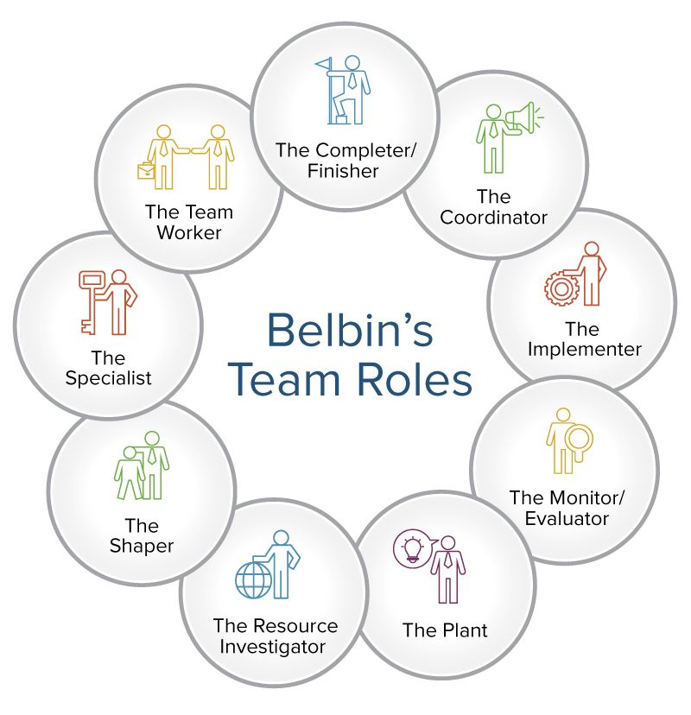

Figure 16 : Belbin’s Theory

**How Authors Team assigned team roles by using Belbin Theory,**

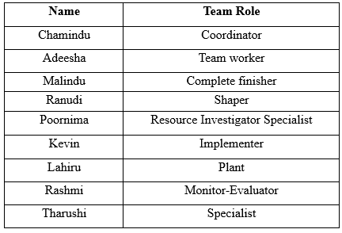

Figure 17 : Team roles using Belbin’s Theory

* **The Shaper**

Extroverts who are shapers often inspire others to follow their example and accomplish goals. They are vibrant, motivated people who can arouse the team's zeal. Shapers are resilient and tend to flourish under pressure despite whatever difficulties they may encounter.

* **Implementer**

Organizers who enjoy order and structure in their surroundings are known as implementers. Implementers are practical individuals who like turning abstract concepts into detailed plans. Implementers are self-controlled, highly disciplined people who can set aside their own interests in favor of the demands of a group or an organization.

* **Completer-Finisher(CF)**

Completers, also known as Finishers, are reserved people who carry out quality control throughout crucial phases of a project. They frequently have a keen eye for detail, which allows them to check completed work or items for flaws. Since these people aim for perfection, they frequently anticipate the same behavior from those around them. To guarantee that teams deliver high-quality work, organizations require these people.

* **Coordinator(CO)**

Coordinators are responsible people with strong communication and interpersonal abilities. Although they frequently hold managerial roles, their management approaches differ greatly from those of Shapers. Coordinators favor a more democratic management style that encourages open dialogue as opposed to Shapers, who operate by instructions.

* **Team Worker(TW)**

Typically outgoing extroverts with amiable personalities, team workers are. They usually have strong listening skills and are skilled at encouraging a team to work together as a unit. Team Workers are inclined to provide aid if they see that other team members aren't handling their workload well. Due to their high levels of adaptability and versatility, these people can deal with rapid changes and engage with a variety of people in productive ways.

* **Resource Investigator(RI)**

Extroverts with a knack for networking are good resource investigators. They are upbeat, passionate individuals who like learning about and investigating novel prospects. Although they might not always have original ideas of their own, they are adept at borrowing concepts from others and bringing them to their own teams.

* **Plant(PL)**

Plants are free-thinking, imaginative beings who generate unique thoughts and provide inventive solutions to problems. Plants like to operate alone, as is the case with the other two thought-oriented occupations.

* **Monitor-Evaluator(ME)**

Instead of acting on impulse or emotion, Monitor Evaluators focus their judgements on the facts and sound reasoning. They are often serious people who excel at strategic planning and critical thinking and have a great propensity to maintain objectivity.

* **Specialist (SP)**

An individual on the team who possesses specialized knowledge is known as the Specialist. They provide insightful advice when a task calls for their field of specialization since they have in-depth knowledge of a certain niche.

**Using Belbin’s Theory in the Leadership Programme**

|  |  |
| --- | --- |
| **Role** | **Description** |
| Shaper | Extroverted and dynamic individuals who inspire others to achieve goals and thrive under pressure, driving the team's enthusiasm. |
| Implementer | Organized individuals who prefer order and structure, turning abstract ideas into concrete plans and staying disciplined and focused. |
| Completer-Finisher | Reserved team members who excel in quality control, paying attention to detail and ensuring high standards in project completion. |
| Coordinator | Responsible team members with strong communication skills and a democratic management approach, fostering open dialogue. |
| Team Worker | Outgoing extroverts with excellent listening skills, adept at promoting team collaboration and offering support to others. |
| Resource Investigator | Extroverts skilled in networking, exploring novel opportunities, borrowing ideas, and bringing them to the team for consideration. |
| Plant | Creative thinkers generating unique ideas and innovative solutions, often working independently in the ideation process. |
| Monitor-Evaluator | Objective individuals who rely on facts and critical thinking to make informed decisions and excel at strategic planning. |
| Specialist | Team members with specialized knowledge in a specific area, providing valuable insights and expertise when needed. |

## 

## The importance of CPD and its contribution to own learning.

### Continuing Professional Development (CPD)

It is a commitment to lifetime learning to engage in continuing professional development. CPD promotes thinking forward and seeing chances to gain new information, brush up on existing knowledge, sharpen skills, or just stay current with the most recent advancements in a specific profession or business.

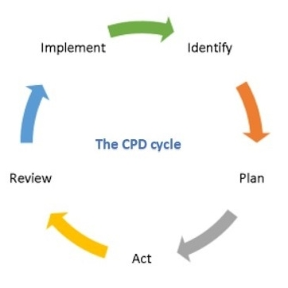

Figure 18: Continuing Professional Development Cycle

CPD performs an essential function in the writer's personal mastering journey, contributing to a non-public and expert boom in the following ways:

**Improve current abilities and study new ones:**

CPD activities and packages offer treasured possibilities to enhance current abilities and study new ones. Through centered education and seminars, authors can broaden numerous talent unit’s tailor-made to enterprise needs, making them extra aggressive within the process market.

**Stay Knowledgeable and as much as date :**

CPD encourages authors to live knowledgeably approximately the contemporary developments, research, and high-quality practices of their enterprise. By sticking to modern-day trends, authors could make knowledgeable selections and live applicable to their field.

**Personal and Career development :**

CPD is extra than only a tick list of publications taken; It represents a complete evaluation of the writer's talent. Participating in CPD promotes non-public empowerment, constructing consideration of one's competence and effectiveness. This, in turn, results in advanced overall performance and process satisfaction.

**Career development Strategy :**

With a well-deliberate CPD strategy, writers can take manage their professional desires and professional boom. By constantly growing their expertise and know-how, they may be higher prepared to capture new possibilities and excel in their selected professional path.

**High -quality service guarantee :**

CPD guarantees that the expertise and abilities required via way of means of the writer to offer customers and the network with expert providers are maintained and enhanced. This dedication to excellence fosters consideration among clients and colleagues.

**Relevancy and Applicability :**

By taking part in CPD, authors make sure that their know-how remains modern-day and applicable. This adaptability permits them to successfully navigate enterprise adjustments and challenges, contributing to their long-time period success

### Importance Of CPD

It is becoming more and more challenging to overestimate the significance of continual professional development as the world's sectors continue to change. CPD gives people the chance to improve their existing abilities and fill in any knowledge gaps, giving them an advantage in situations when they might need it, like a job interview. CPD can help people stand out in the job market because numerous applicants for certain positions frequently possess comparable essential credentials. Individuals may control their professional progress and objectives by using a planned CPD strategy. The sense of personal empowerment that comes with having professional autonomy may boost self-assurance in one's competence and effectiveness, which immediately translates into better job output. Employees are likely to be more motivated and devoted to a firm, which helps employers as well.

### How CPD Helpful to contributing to author’s own learning.

* CPD events and programs offer chances to improve and expand already-existing skills or learn new ones.
* Professionals are encouraged by CPD to keep informed on the most recent developments, research, and best practices in their industry.
* It does not serve as a checklist of the author's education.
* More is involved than that Provides a comprehensive look into the author's skill set.
* It makes sure that the information and abilities needed to offer customers and the community a professional service are preserved and enhanced.
* Assures that the author's expertise is up to date and applicable

In summary, CPD is an effective device that permits people to constantly study and development of their expert careers. The author's dedication to CPD makes him aggressive, knowledgeable, and adaptable, which in the long run results in higher process overall performance and general professional success.

## A development plan that outlines responsibilities, performance objectives and required skills, knowledge and learning for future goals.

* Authors Personal Development plan(PDP)

|  |  |  |  |  |  |  |  |  |  |  |  |  |  |  |  |  |
| --- | --- | --- | --- | --- | --- | --- | --- | --- | --- | --- | --- | --- | --- | --- | --- | --- |
| **Name :** | | | | | | | | **Current position:** | | | **Date Started:** | | | | | |
| Ranudi Gayathmie Kariyapperuma | | | | | | | | Student | | | 7/8/2023 | | | | | |
| **Career Mission Statement**( What you intend to accomplish and why) | | | | | | | | | | | | | | | | |
| To be a Lecturer | | | | | | | | | | | | | | | | |
| **Major Career Goals** ( What you need to accomplish in the medium term to further your mission) | | | | | | | | | | | | | | | | |
| **Goal :** | Complete Higher National Diploma | | | | **Targeted Date:**  05/09/2023 | | | | **Goal :** | Complete top up Degree | | | | **Targeted Date :**  2026 December | | |
| **Goal :** | Complete B.Sc. Hons in Technology Management Degree | | | | **Targeted Date:**  22/01/2026 | | | | **Goal :** | To go abroad | | | | **Targeted Date:**  2027 August | | |
| **Skills Audit**  **A :I have accomplished this skill / I demonstrate high competence**  **B :I have this skill / Competency, but some improvements could be made**  **C :I need to improve this skill/competency**  **D :I need to put in considerable work to develop the skill/ competency**  **E : I need to acquire this skill/ develop this competency** | | | | | | | | | | | | | | | | |
| **Skill / Competency** | | **RANK** | | | | | **Skill / Competency** | | | | | **RANK** | | | | |
| **Now** | **6m** | **1yr** | | **3yr** | **Now** | **6m** | | **1yr** | **3yr** |
| Problem Solving | | D | C | B | | A | Active listening | | | | | B | A | |  |  |
| Motivation | | B | A |  | |  | Time Management | | | | | C | B | | A |  |
| Patience | | B | A |  | |  | Leadership Skills | | | | | C | B | | A |  |
| Research | | D | C | B | | A | Team Work | | | | | B | A | |  |  |

## A professional schedule to support the planning of an event, to include contingencies and justifications of time allocated.

### Gantt Chart

The graphical representation of a project schedule that is most frequently used is the Gantt chart. It is a specific kind of bar chart that displays the beginning and ending dates of several project components, including resources, planning, and dependencies. So in authors team members also made a Gantt chart to schedule the activities to do . In the bellow is the Gantt chart that authors team was made.

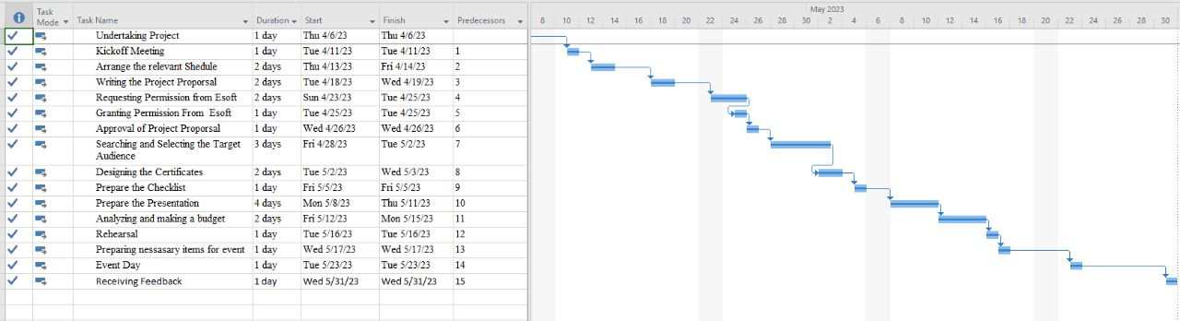

Figure 19 : Author’s Teams Gantt Chart

In this Gantt chart blue bars show the time period of each activity, and it also shows how it flows. In Left side there is a column called task name in there can listed each activity. In the second column there can be entered the duration and in other two columns can enter start date of the activity and the finish date of the activity. Using this Gantt chart, it easy to plan the whole event in there and each activity can be scheduled in this.

## The use and application of a range of solution methodologies.

A solution method is a particular strategy, methodology, or procedure used to resolve an issue or meet a particular difficulty. It gives the process of addressing problems a systematic framework or series of processes. Solution techniques are intended to assist people or teams in methodically analyzing a challenge, locating viable fixes, and putting the best plan of action into action.

### Application of Solution Methodologies.

* Firstly, user should understand the problem.
* Then the problem should have to analyze according to it
* After That define the actual output of the problem.
* Research solutions methodology for the problem
* Collect the resources that needed.
* Select the Most suitable solution Methodology for the Problem
* Apply the selected solution methodology for the problem.
* Look after the progress of It.
* Review and documenting this problem and how it were solve.

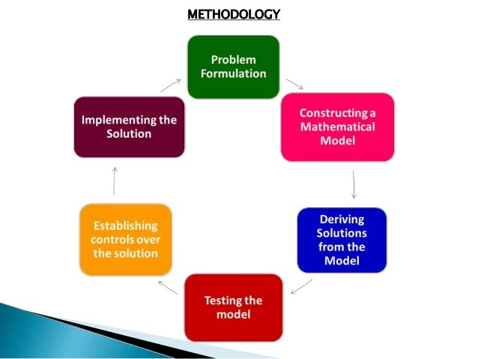

Figure 20 : Solution Methodology

## Differences between different motivational theories and the impact they can have on performance within the workplace.

Understanding what motivates someone to work for a specific end or goal is the subject of motivation theory. Though it applies to every aspect of society, business, and management stand to gain the most from it. This is true because motivated employees are more productive, and productive employees produce more revenue.

### Different Motivational theories

#### Maslow’s Hierarchy of Needs

This Motivational theory was firstly introduced by Abraham Maslow in 1943. This is 5 tier hierarchical levels with a pyramid model that includes human needs. This hierarchical model flows from bottom to upwards . As it mentioned the basic human needs that included in this hierarchical model are,

* Physiological needs
* Safety Needs
* Love and belonging
* Esteem
* Self-actualization

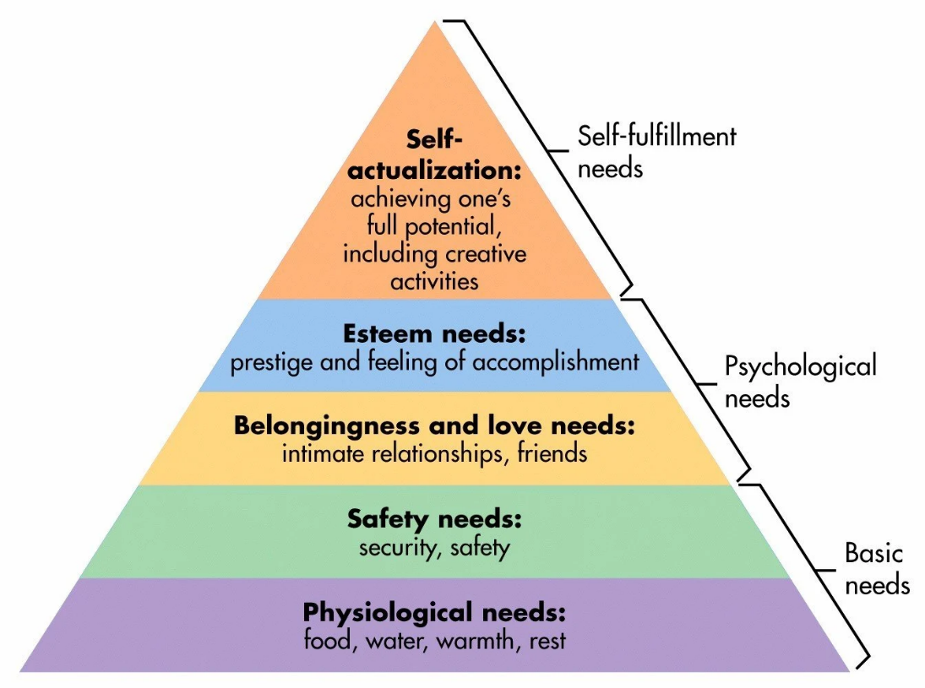

Figure 21 : Maslow’s Hierarchy of Needs

#### Herzberg’s Two Factor Theory of Motivation

A two-factor theory, often known as the motivator-hygiene theory, was suggested in

1959 by Frederick Herzberg, a psychologist. According to Herzberg, certain

employment variables contribute to satisfaction while others shield employees against

unhappiness. In This theory the two factors are,

**Hygiene Factors**

Job characteristics that are important in maintaining motivation at work include those

that are related to hygiene. Long-term positive satisfaction is not produced .

**Motivational Factors**

Herzberg contends that hygiene issues cannot be viewed as motivators. Positive

satisfaction is produced by the motivating causes. These elements are part of work by

nature. These elements push workers to do excellent work.

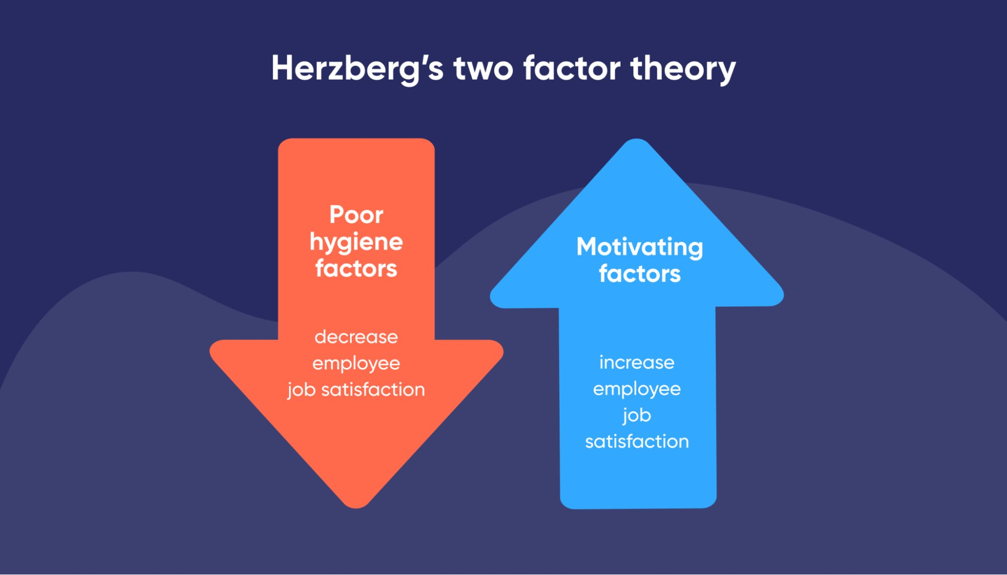

Figure 22 : Herzberg’s two factor theory

* **McClelland’s Theory of Needs**

A certain theory that defines this process of motivation by describing desire and

describing how they should be met is McClelland's theory of needs. American

psychologist David McClelland developed this theory. In this theory there are 3 aspects

that are known as,

* Need for Power
* Need of Affiliation
* Need of Achievement

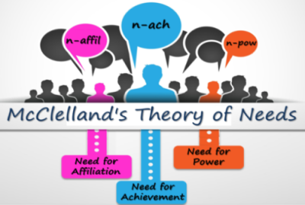•

Figure 23 : McClelland’s Theory of Needs

* **Vroom’s theory of Expectancy**

The idea behind it is that individuals will seek to minimize suffering and maximize pleasure. In other words, individuals will act in a way that yields the best result or reward. The theory depends on the idea that an employee will be more motivated to achieve a goal should  value it more. The contents of this theory are ,

* Expectancy
* Instrumentality
* Valence

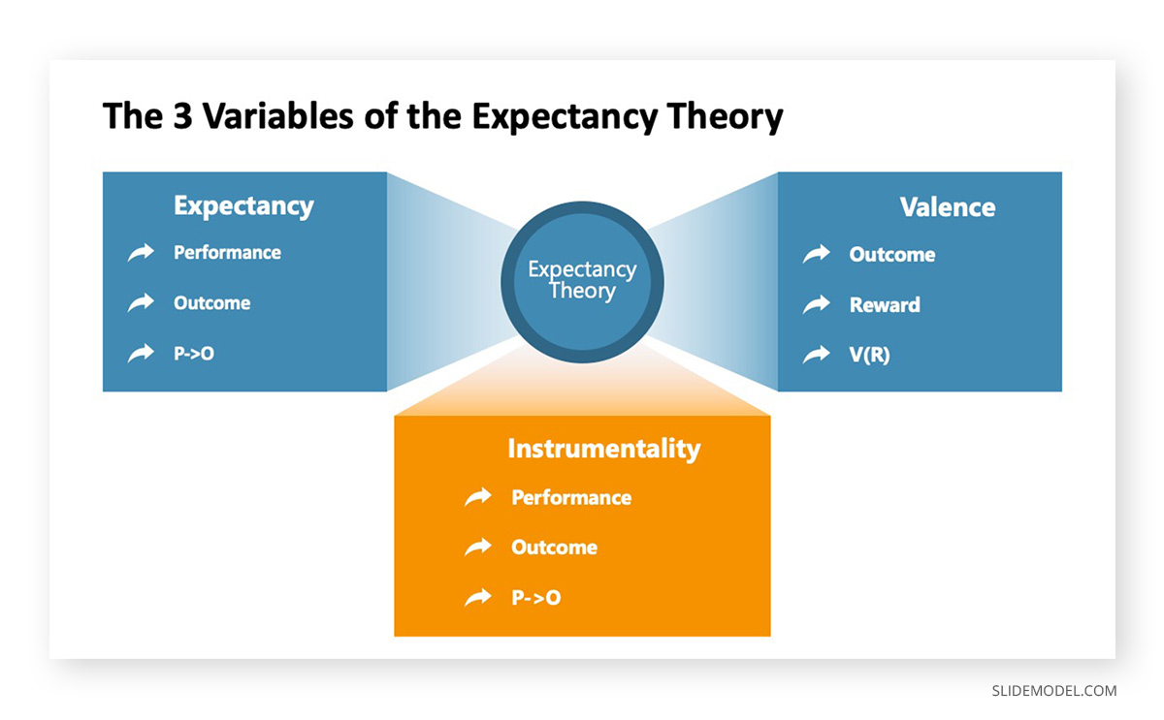

Figure 24 : Vroom’s theory of Expectancy

* **McGregor’s theory X and theory Y**

This theory was developed by Douglas McGregor. The idea requires managers to have motivational skills. It's important to note that different rewards encourage various types of workers.

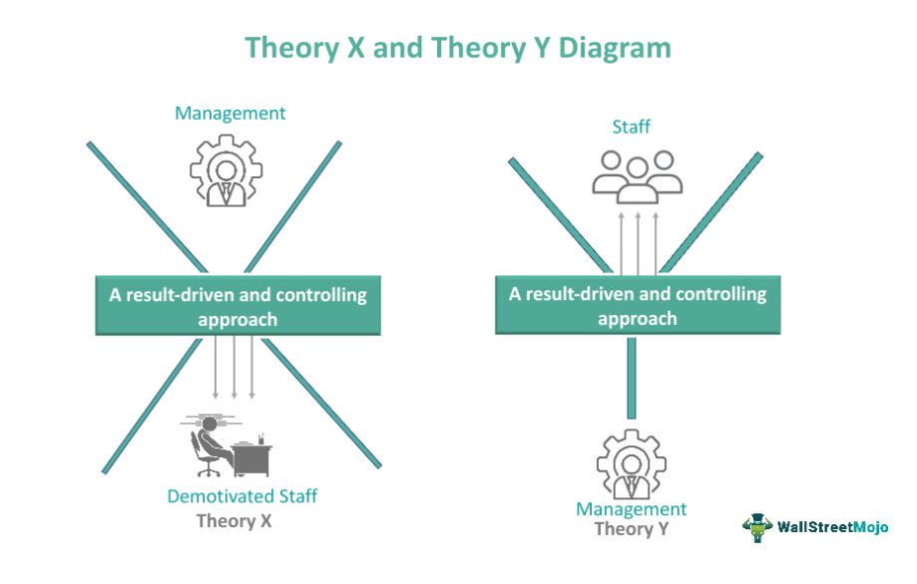

Figure 25 : McGregor’s theory X and theory Y

### Motivational Theory Comparison

|  |  |  |  |  |
| --- | --- | --- | --- | --- |
| Maslow’s Hierarchy of Needs | Herzberg’s Two Factor Theory of Motivation | **McClelland’s Theory of Needs** | **Vroom’s**  **theory of**  **Expectancy** | **McGregor’s theory X and theory Y** |
| Physiological needs |  |  |  |  |
| Safety Needs | Hygiene Factors | Need for Power | Expectancy | X theory |
| Love and belonging |  | Need of Affiliation | Instrumentality |  |
| Esteem | Motivational Factors | Need of Achievement | Valence | Y theory |
| Self-actualization |  |  |  |  |

**Application of Motivational Theories in the Workplace and Leadership Training Event for DTEC students of Esoft**

|  |  |
| --- | --- |
| **Motivational Theory** | Maslow's Hierarchy of Needs |
| **Application in the Workplace** | In the workplace, managers can identify and address the physiological needs of employees by providing them with a safe and comfortable work environment, with breaks and refreshments, and fair pay. Safety needs can be met through appropriate training, clear work assignments, and ensuring a safe work environment. To meet the need to love and belong together, it can be effective to foster a positive work culture, encourage teamwork, and organize team-building activities. For the sake of respect, it is possible to recognize and reward employees for their achievements, create opportunities for development, and recommend promotions. |
| **Application in Leadership Training Event** | During a leadership training event, moderators can emphasize the importance of meeting employees' basic needs first in order to create a supportive work environment. Participants can participate in group discussions to identify strategies to address these needs within their group. Alternatively, training can focus on developing leadership skills that foster a sense of belonging and create a supportive environment for team members. In addition, participants can learn ways to provide constructive feedback and recognition, thereby helping to build respect among subordinates. |
| **Motivational Theory** | Herzberg's Two Factor Theory of Motivation |
| **Application in the Workplace** | In the workplace, managers can focus on providing hygiene factors, such as competitive wages, job security, and good working conditions, to prevent employee dissatisfaction. To motivate employees, the focus should be on incorporating motivational factors, such as challenging tasks, growth opportunities, and recognition of achievement. This helps create a positive and satisfying work experience for employees. |
| **Application in Leadership Training Event** | During a leadership training event, moderators can educate participants on the importance of maintaining hygiene factors to avoid losing motivation in their team. Discussions and case studies can be used to emphasize the importance of providing motivational factors to inspire outstanding performance. Role-playing exercises can be used to demonstrate how leaders can effectively recognize and reward team members, thereby fostering a motivating work environment. |
| **Motivational Theory** | McClelland's Theory of Needs |
| **Application in the Workplace** | In the workplace, managers can assess the individual needs of employees. For those with a need for power, being given leadership and decision-making responsibilities can be motivating. For those who need bonding, creating a collaborative work environment and encouraging group activities can be effective. For employees who need to succeed, offering challenging tasks, opportunities to develop skills, and setting clear performance goals can increase motivation. |
| **Application in Leadership Training Event** | During leadership training, participants can self-assess to identify their priority needs. The coach can then support them to adapt their leadership style and respond to these needs. Role-play scenarios can be used to practice motivating people with different needs and adapt their leadership strategies. Group discussions can encourage participants to share their experiences and best practices for cultivating diverse groups. |
| **Motivational Theory** | Vroom's Theory of Expectancy |
| **Application in the Workplace** | In the workplace, managers can increase motivation by directly linking rewards to performance. By setting clear performance expectations and ensuring that employees understand the link between effort, performance, and reward (value), motivation can be improved. In addition, managers can create a work environment where employees believe that their efforts will lead to desired results (expectations) and rewards will be distributed fairly (fairness). |
| **Application in Leadership Training Event** | During the leadership training event, participants can engage in activities that demonstrate the importance of aligning rewards with performance. They can explore ways to raise the expectations of their team members by providing the support and resources needed to succeed. Facilitators can also discuss strategies to ensure fairness and transparency in reward distribution, thereby maintaining motivation and trust in groups. |
| **Motivational Theory** | McGregor's Theory X and Theory Y |
| **Application in the Workplace** | In the workplace, Theory X managers may assume that employees are naturally lazy and need close supervision. In contrast, Theory Y managers believe that employees are motivated and can develop autonomy and responsibility. Understanding these different leadership styles can help managers tailor their approach to employees' attitudes and preferences. Theory Y management can lead to a more positive and motivating work environment. |
| **Application in Leadership Training Event** | Leadership training allows participants to explore Theory X and Theory Y management styles to understand their impact on employee motivation and performance. Case studies and focus groups can be used to analyze situations where both styles are appropriate. Through role-playing exercises, participants can practice using Theory Y management techniques such as delegation and delegation to promote motivational leadership. |

## The effectiveness and application of interpersonal skills during the design and delivery of a training event.

When the Authors team was preparing for the event members conducted meetings to find each person’s skills and in order to that then gave the positions to each other to do the event perfectly. In below chart is the Authors team members interpersonal skills and roles that were assigned.

|  |  |  |  |
| --- | --- | --- | --- |
| **Register No** | **Name** | **Interpersonal Skills** | **Team Role** |
| 00104185 | Chamindu Kavishka Gunaratne | * Communication * Leadership * Problem solving * Active Listening * Motivation * Responsibility | Team Leader and Presenter |
| 00102601 | Adeesha Abeykoon | * Creativity * Teamwork * Active Listening * Flexibility * Communication | Team Member |
| 00104243 | Ranudi Gayathmie Kariyapperuma | * Leadership * Active Listening * Responsibility * Creativity * Coordinating | Vice Team Leader |
| 00150025 | Malindu Baddegama | * Selflessness * Teamwork * Coordinating * Problem solving | Team Member |
| 00132440 | Poornima Rasini Jayarathna | * Teamwork * Flexibility * Active Listening * Dependability | Team Member |
| 00131382 | Sivachandrasekara Raja Kevin Gimsara Prisley | * Coordinating * Teamwork * Creativity * Communication | Secretary |
| 102555 | Lahiru Prakash Sandaruwan | * Teamwork * Trust Honesty * Responsibility * Flexibility | Team Member |

## A critical evaluation of Authors owns role and contribution to a group scenario.

In Authors Team the author was the Vice team leader in the Team and as mentioned when if the leader unable to do something the author was able to do that kind of stuff. As a Vice leader author look after every members work stuff and if there any problems Author solve the problems or author will give it to the team leader to looked after that and also when discussed about the planning event author and the Team leader was listening to the other members that when asked about what kind of game that the team had to choose so as a team authors team was very friendly and always helpful to others .

Author also gives information’s to others if the other members unable to join to meeting . Also, if any member needs a help to find information of the event or questions about it author will give the all information that needed every time and authors team had a WhatsApp group so author will always update all the information through the WhatsApp if the leader unable to do them.

Also, when preparing the game for the event author collects the needed items .For an example authors group was chosen the Tower challenge game for that needed newspapers so the Author and the other members also found newspapers and author divided the newspapers and other stuff into six groups and after that author give separately to the lecturer before the event .

So as a team member or vice leader author also didn’t know how to evaluate authors works. To evaluate the role of own author used several methods to evaluate own role . First step to find self-reflection. It means that author should find the strengths and weaknesses of own . so, as the findings authors strengths were good leadership, positive thinking and the weakness were afraid of public speaking. So, to avoid weakness author practice hard to avoid the afraid of public speaking . Also, in self-reflection author found about the past projects and get and idea about the project and told the team leader and team about it and as a team we did a different game and did the event differently.

So, the second step the author used is seek feedback. To find the seek feedback author ask the team members and the team leader to give the honest feed back of authors. At that time the team members were support to that and give the honest answer and the team leader said that the authors work is very quick and do them perfectly. Then the third step is that to set clear objectives to do that author was set to a role of called problem solving and manage the team work . As the vice leader of the team author was solve problems that came to the group such as when a team leader unable to do the work always author look after them and when the lecturer told us to give the items to do the game that day some of team members and the team leader were not there so to fix that problem author at the end of the day give the items to the lecturer. So it is very hard to do the role of problem solving and also the other role is to manage the team work in that time author look after the members problems and the work of them and manage them perfectly.

Fourth step is to develop the communication skills . As a team member author always do the things author always ask the ideas about the plan from team members and the team leader and listen to there ideas. It is very import to connect with each other good communication will always give good benefits .

The last step is to look after the authors contribution to the team. So always author look the team work and look the things that didn’t done to the team and do them to do a perfect event.

As the conclusion it was very effective to do such an event it also developed authors and team members interpersonal skills.

## A range of evidence criteria that is used as a measure for effective CPD.

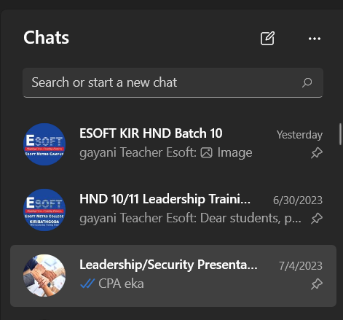

Figure 26: WhatsApp groups that used for the Event planning

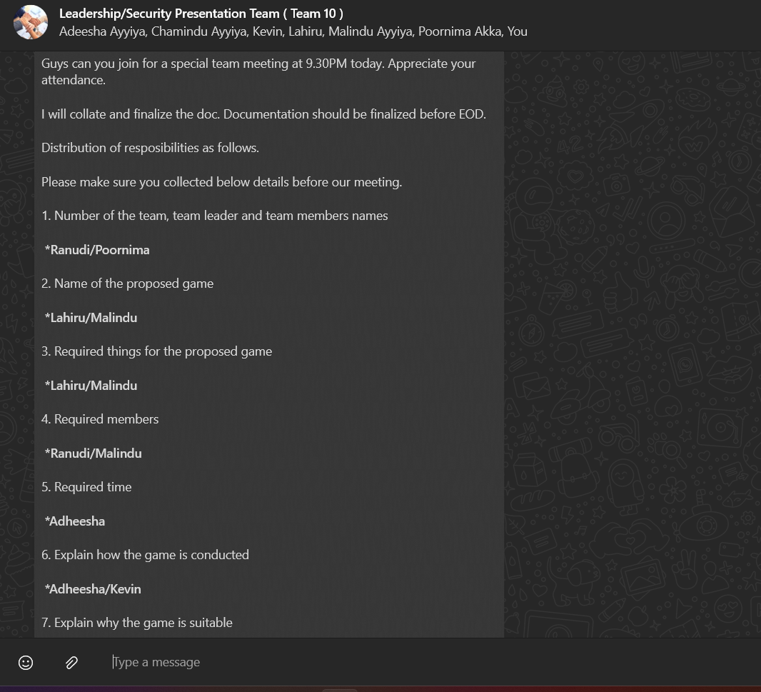

Figure 27 : The authors teams WhatsApp group

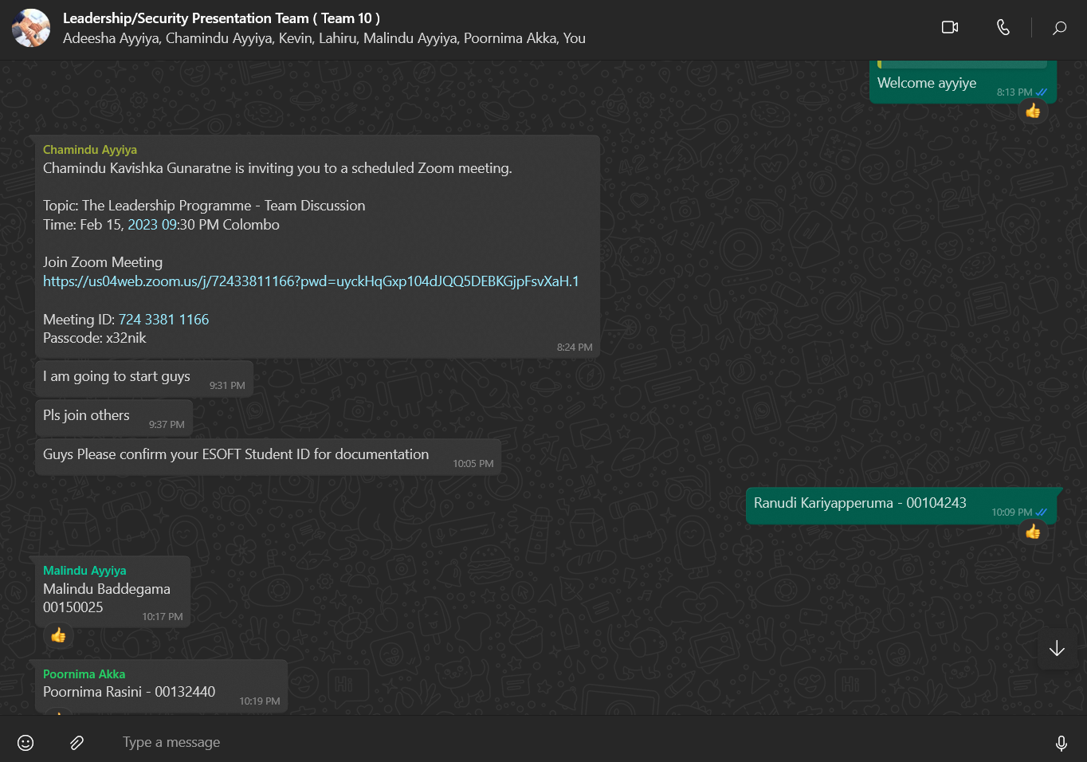

Figure 28 : Authors teams Zoom meetings



Figure 29: Authors teams Meetings

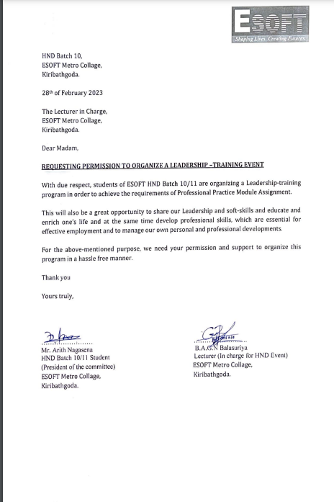

Figure 30 : Event Permission Letter 1

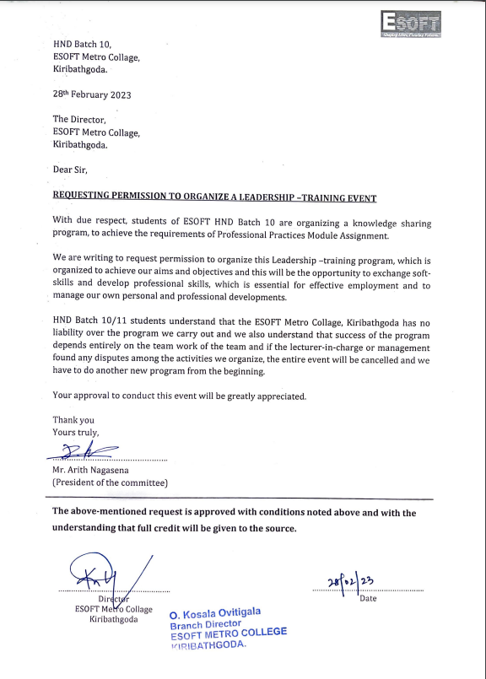

Figure 31 : Event Permission Letter 2

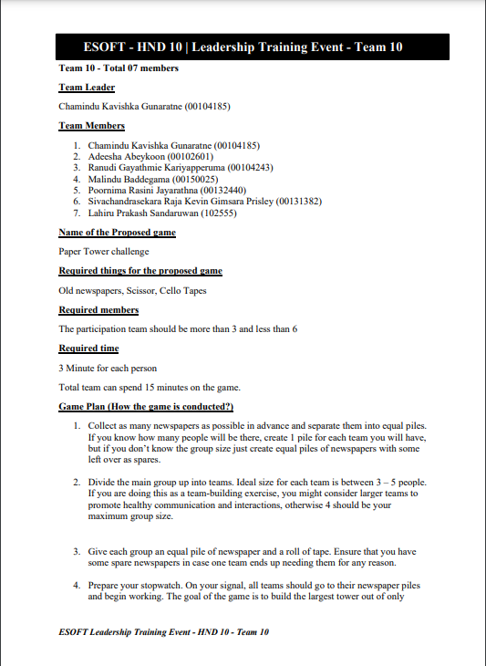

Figure 32 : Authors Team Project proposal 1

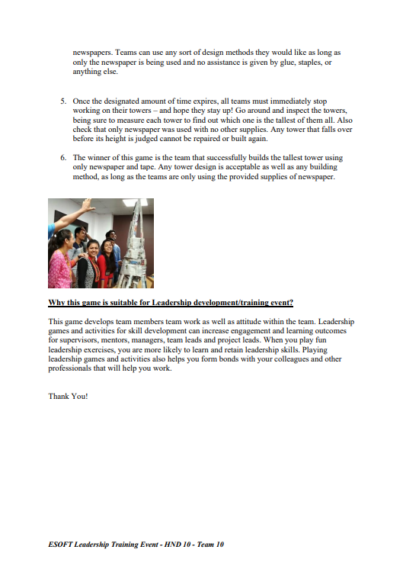

Figure 33 : Authors Team Project proposal 2

### Event photos

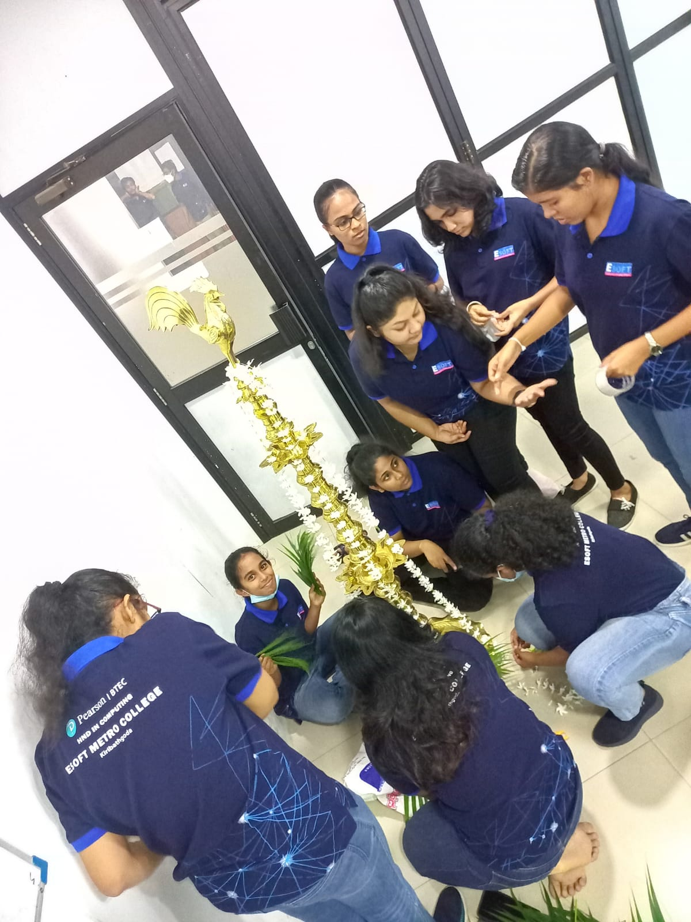

Figure 34 : preparing the event

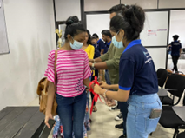

Figure 35 : Tie a colour ribbon to define the groups for each student

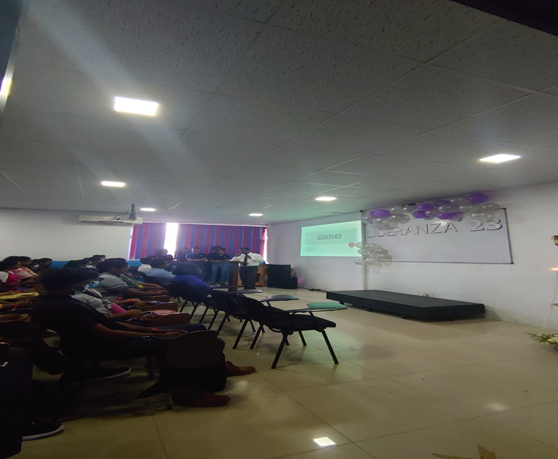

Figure 36 : Before the event

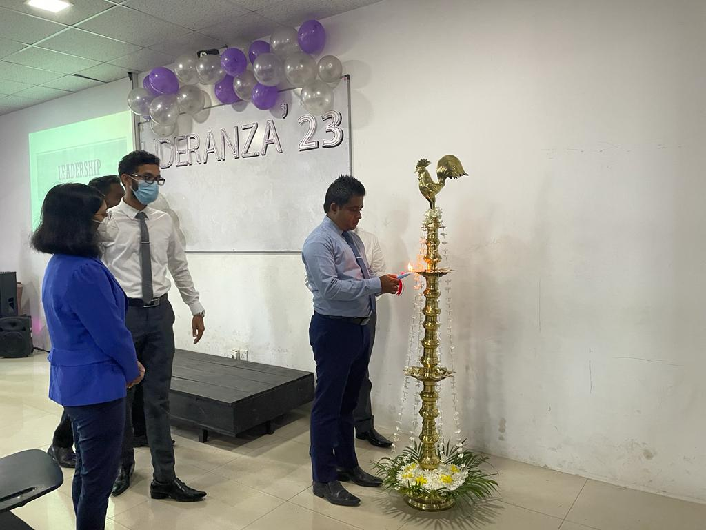

Figure 37 : The beginning of the event

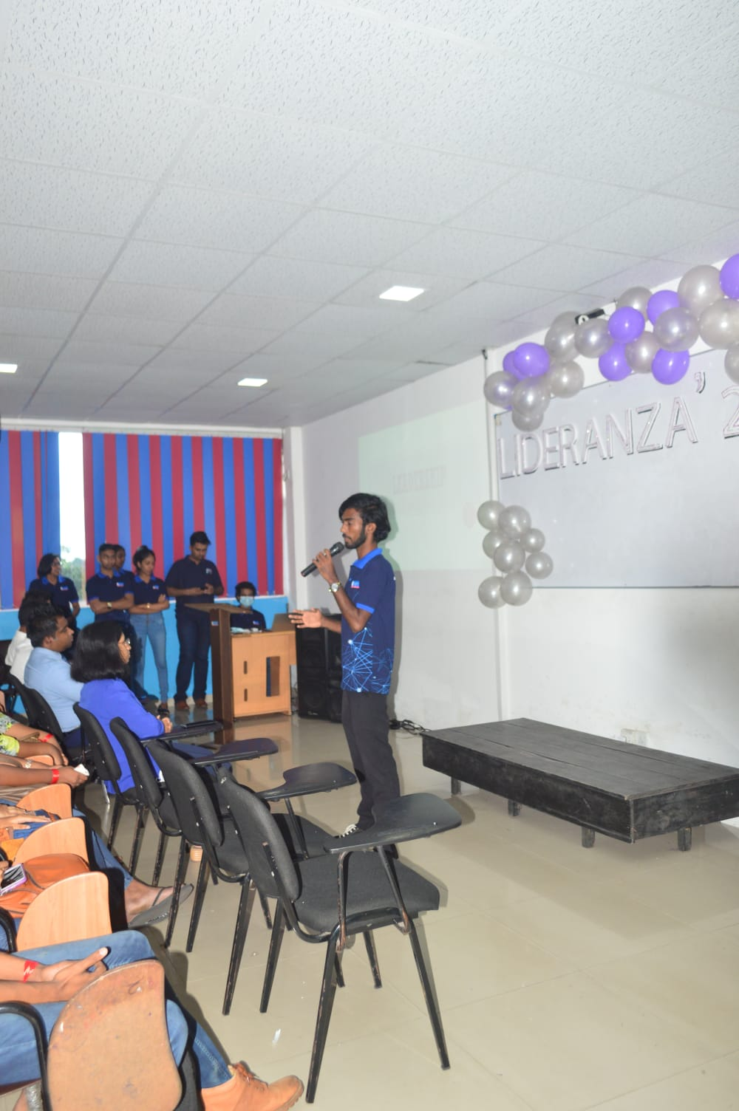

Figure 38 : Presentations

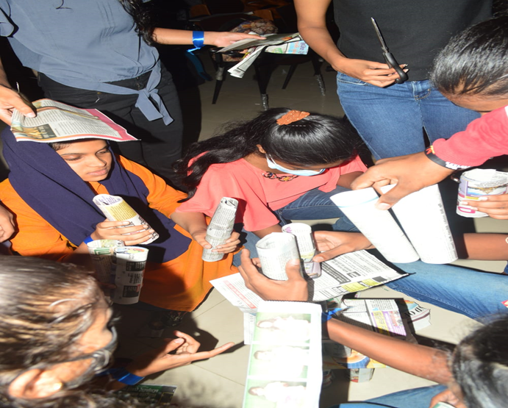

Figure 39 : Paper tower challenge

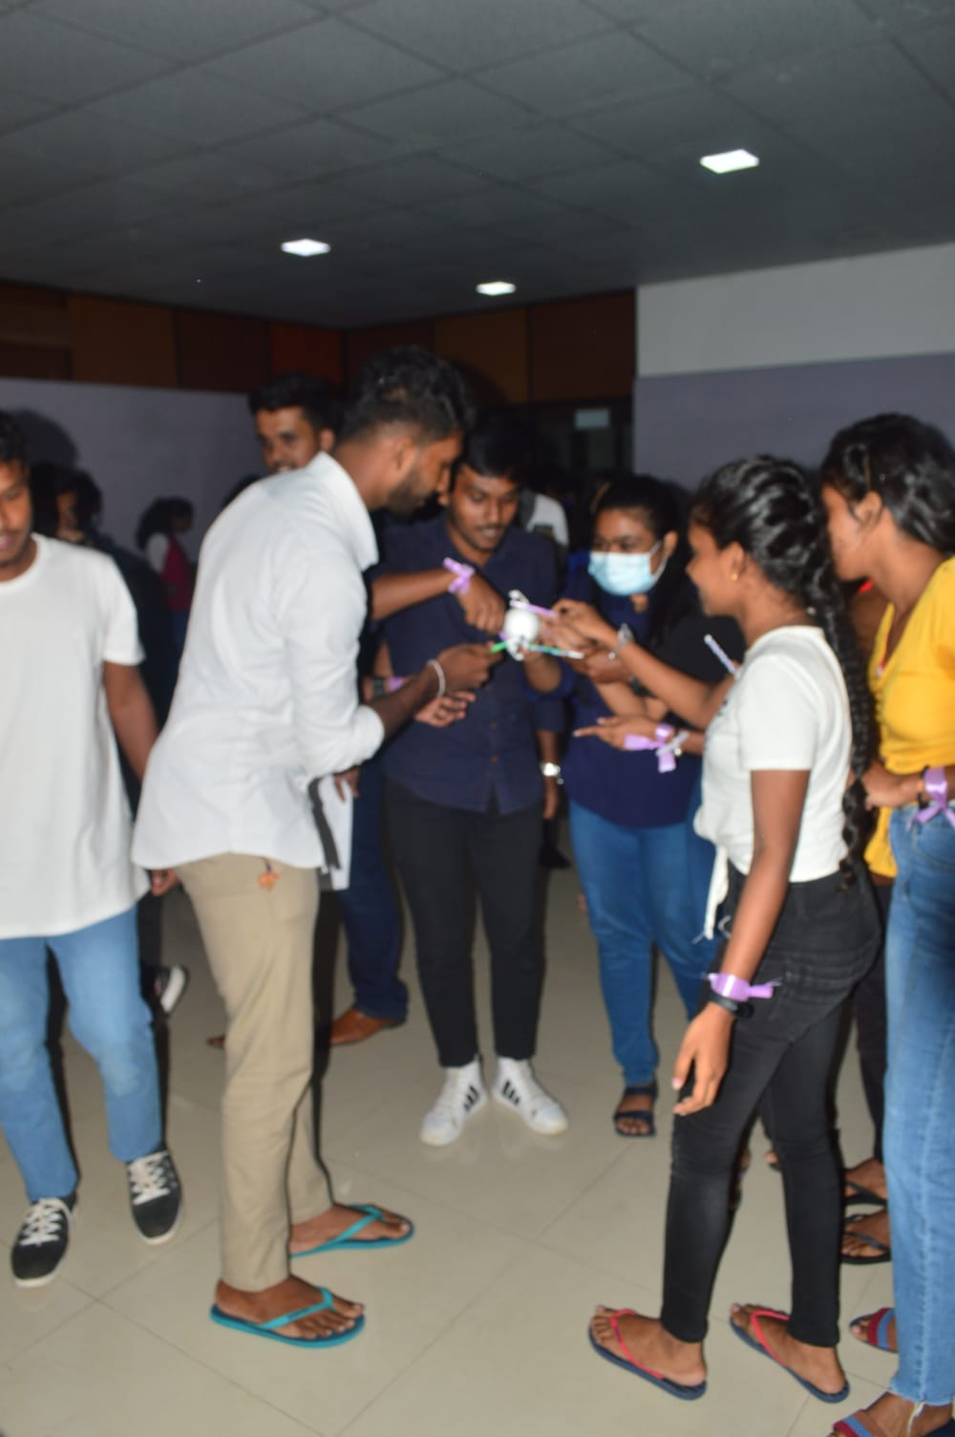

Figure 40 : Sketch pen game

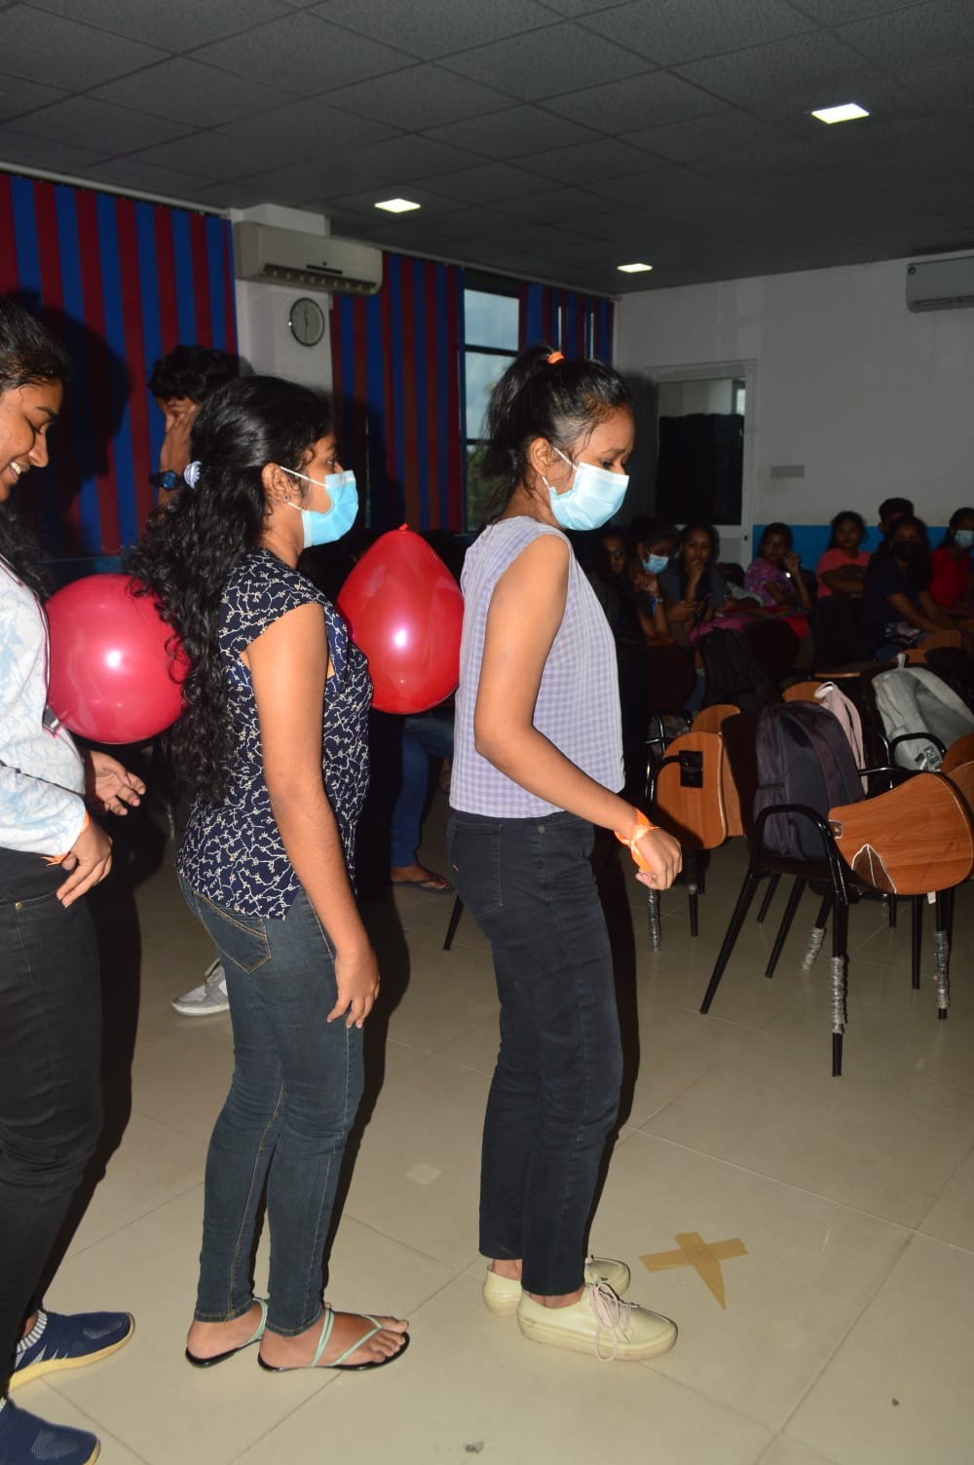

Figure 41 : Ballon hub game

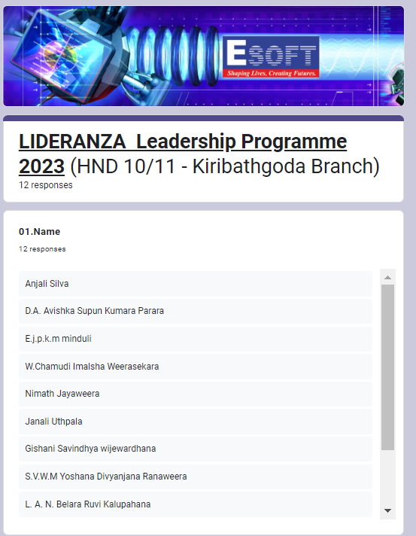

Figure 42 : Feedbacks about the Event 1

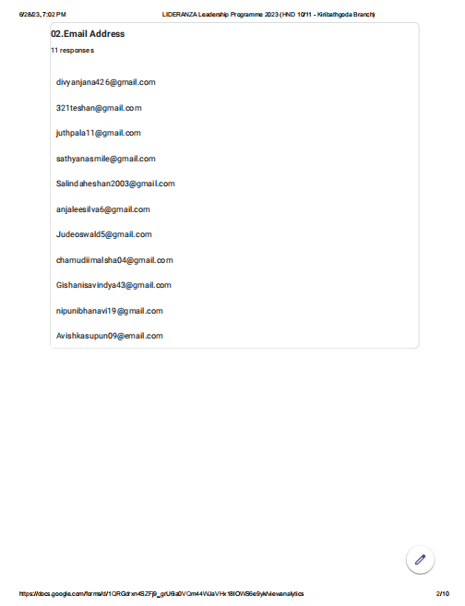

Figure 43 : Feedbacks about the Event 2

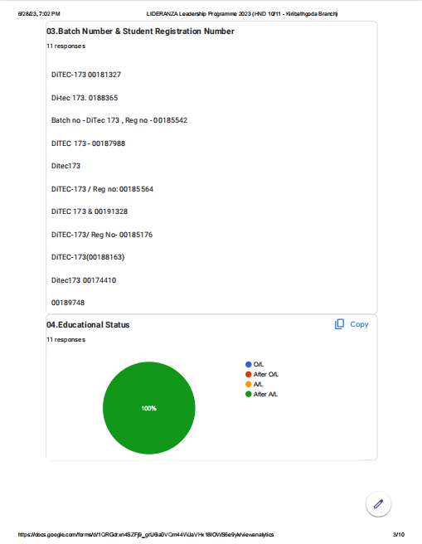

Figure 44 : Feedbacks about the Event 3

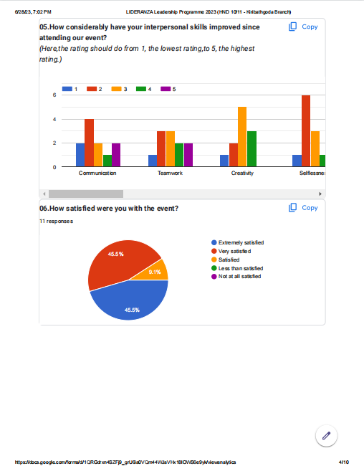

Figure 45 : Feedbacks about the Event 4

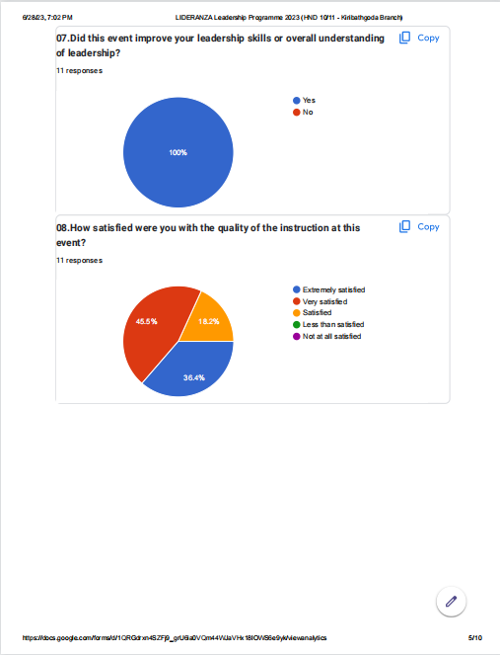

Figure 46 : Feedbacks about the Event 5

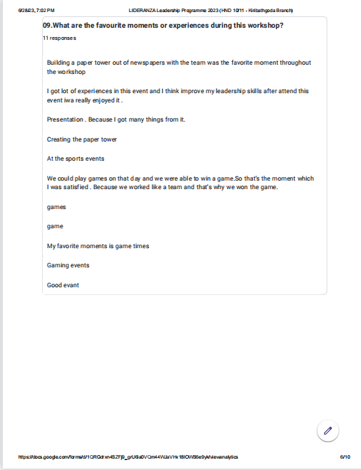

Figure 47 : Feedbacks about the Event 6

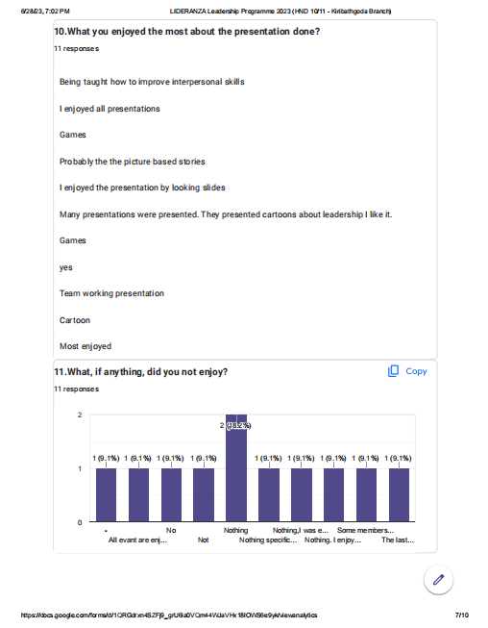

Figure 48 : Feedbacks about the Event 7

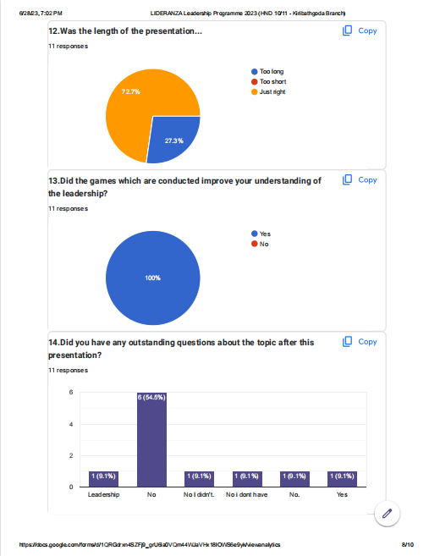

Figure 49 : Feedbacks about the Event 8

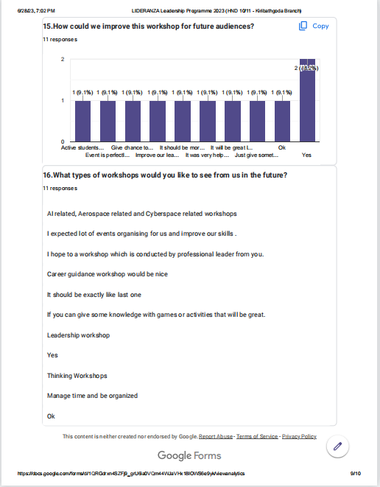

Figure 50: Feedbacks about the Event 9

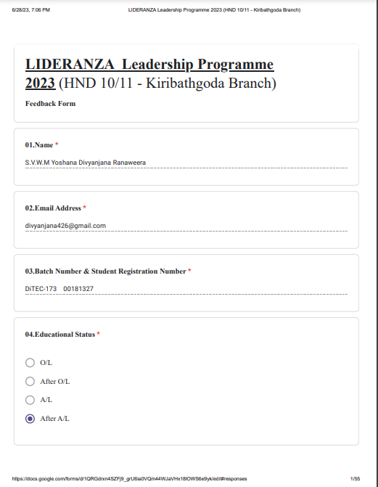

Figure 51 : Feedbacks about the Event 10

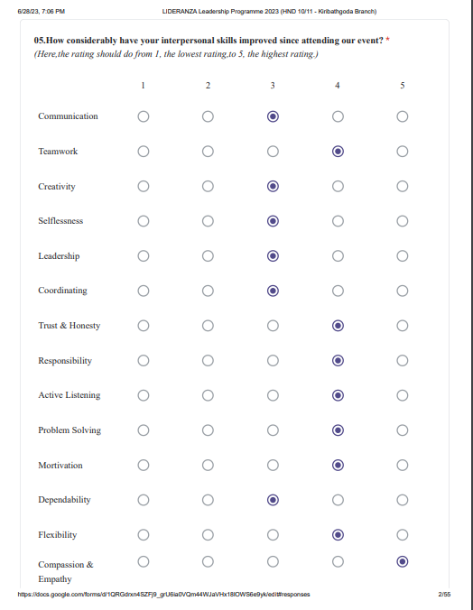

Figure 52 : Feedbacks about the Event 11

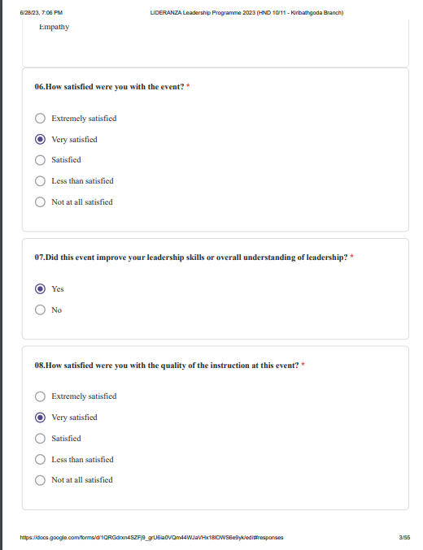

Figure 53 : Feedbacks about the Event 12

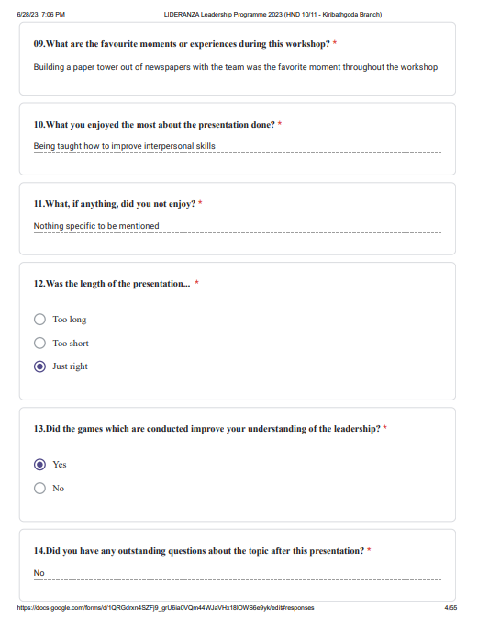

Figure 54 : Feedbacks about the Event 13



Figure 55 : Feedbacks about the Event 14

# References

Anon., n.d. *SKILLSYOUNEED.* [Online]   
Available at: https://www.skillsyouneed.com/ips/interpersonal-communication.html

Bernstein, C., n.d. *Techtarget.* [Online]   
Available at: https://www.techtarget.com/whatis/definition/brainstorming#:~:text=Brainstorming%20is%20a%20group%20problem,based%20on%20their%20diverse%20knowledge.

Keiling, H., 2023. *Indeed.* [Online]   
Available at: https://www.indeed.com/career-advice/career-development/time-management-skills  
[Accessed 04 February 2023].

Kenton, W., 2021. *Investopedia.* [Online]   
Available at: https://www.investopedia.com  
[Accessed 3 February 2021].

Mcleod, S., 2023. *Simply Psychology.* [Online]   
Available at: https://www.simplypsychology.org/maslow.html  
[Accessed 7 July 2023].

Team, C., 2020. *CFI.* [Online]   
Available at: https://corporatefinanceinstitute.com/resources/management/maslows-hierarchy-of-needs/  
[Accessed 07 July 2023].

**Grading Rubric**

|  |  |  |
| --- | --- | --- |
| **Grading Criteria** | **Achieved** | **Feedback** |
| **LO1** **Demonstrate a range of interpersonal and transferable communication skills to a target audience**. |  |  |
| **P1** Demonstrate, using different communication styles and formats, that you can effectively design and deliver a training event for a given target audience. |  |  |
| **P2** Demonstrate that you have used effective time management skills in planning an event. |  |  |
| **M1** Design a professional schedule to support the planning of an event, to include contingencies and justifications of time allocated. |  |  |
| **D1** Evaluate the effectiveness and application of interpersonal skills during the design and delivery of a training event. |  |  |
| **LO2** **Apply critical reasoning and thinking to a range of problem-solving scenarios.** |  |  |
| **P3** Demonstrate the use of different problem-solving techniques in the design and delivery of an event. |  |  |
| **P4** Demonstrate that critical reasoning has been applied to a given solution. |  |  |
| **M2** Research the use of different problem-solving techniques used in the design and delivery of an event. |  |  |
| **M3** Justify the use and application of a range of solution methodologies. |  |  |
| **D2** Critique the process of applying critical reasoning to a given task/activity or event. |  |  |
| **LO3** **Discuss the importance and dynamics of working within a team and the impact of team working in different environments**. |  |  |
| **P5** Discuss the importance of team dynamics in the success and/or failure of group work. |  |  |
| **P6** Work within a team to achieve a defined goal. |  |  |
| **M4** Analyse team dynamics, in terms of the roles group members play in a team and the effectiveness in terms of achieving shared goals. |  |  |
| **D3** Provide a critical evaluation of your own role and contribution to a group scenario. |  |  |
| **LO4 Examine the need for Continuing Professional Development (CPD) and its role within the workplace and for higher-level learning.** |  |  |
| **P7** Discuss the importance of CPD and its contribution to own learning. |  |  |
| **P8** Produce a development plan that outlines responsibilities, performance objectives and required skills, knowledge and learning for own future goals. |  |  |
| **M5** Compare and contrast different motivational theories and the impact they can have on performance within the workplace. |  |  |
| **D4** Evaluate a range of evidence criteria that is used as a measure for effective CPD. |  |  |